**Steganography Project Final Report**

Linden Crandall, Jonathan Mainhart, Zhihua Zheng

University of Maryland Global Campus

CMIS 495: Current Trends and Projects in Computer Science

Prof. Majid Shaalan

May 8, 2022

Table of Contents

List of Figures 4

List of Tables 4

Overview 5

Individual Contributions: 5

Project Plan 5

Requirements Specification 6

User Guide 6

Test Plan and Results 6

Design and Alternate Designs 7

Development History 7

Phase I 7

Phase II 8

Phase III 9

Final Submission 9

Conclusion 9

Lessons Learned 9

Design Strengths 10

Design Limitations 10

Future Improvements 11

APPENDIX A: Steganosaurus User’s Guide 9

About This Application 9

System Requirements 9

Windows 10

macOS 10

Linux 10

Getting Started 10

How To 10

Choose an Image 10

Decode an Image 11

Encode an Image 11

Reset an Image 11

Save an Image 11

APPENDIX B: Test Plan and Results 12

Introduction 12

Test Systems 12

Test Cases 12

Results 21

APPENDIX C: Project Design 38

Project Overview 38

Main Goals 38

Design Concept 38

File Structure 39

File Access 39

Data Structures 39

Input and Output 40

Typical User Interaction 40

User Interface 41

GUI Overview 41

User Notification Dialog 43

Message Encoding and Decoding 44

Encoding an Image 44

Decoding an Image 45

Resetting an Image 45

Class, Attributes, and Methods 45

# List of Figures

Figure 1. System 2 automated unit test results. 21

Figure 2. The application loads a randomized image when launched and decodes the secret message (manual test cases 4-1 and 4-2). 22

Figure 3. Results of clicking the “Open Image” button. The application has access to the file system (manual test cases 4-3 and 4-4). 23

Figure 4. Results of attempting to open a ineligible file (Test case 4-5). 24

Figure 5. The application opens image files as expected (Test case 4-6). 25

Figure 6. The remaining characters allowed decrease as text is input (Test case 4-8). 26

Figure 7. Entering too many characters displays a warning (Test case 4-9). 27

Figure 8. Attempting to encode an image with too many characters (Test case 4-10). 27

Figure 9. A message of the correct length will encode (Test case 4-11). 28

Figure 10. Save dialog (Test case 4-12). 29

Figure 11. Attempting to save a file with an invalid name (Test case 4-13). 30

Figure 12. Successfully saving an image with default encoding (Test case 4-14). 31

Figure 13. Successfully saving an image as JPEG (Test case 4-15). 32

Figure 14. Attempting overwrite triggers warning (Test case 4-17). 33

Figure 15. The files have been overwritten (Test case 4-17). 34

Figure 16. Reset button triggers warning (Test case 4-18). 35

Figure 17. Image resets (Test case 4-18). 36

Figure 18. Image is decoded when opened (Test case 4-20). 37

Figure 19. File structure 39

Figure 20. Logic Control Flow of a typical user interaction 41

Figure 21. Graphical User Interface 42

Figure 22. Info and error message popup dialog 43

Figure 23. Warning message popup dialog 44

# List of Tables

Table 1: Phase I Milestone Status Table 7

Table 2: Phase II Milestone Status Table 8

Table 3: Phase III (Week 7) Milestone Status Table 9

Table 4 Test Systems 12

Table 5 Automated Unit Tests (Back End) 12

Table 6 Automated Unit Tests (Front End) 13

Table 7 Manual Tests 19

Table 8**:** stego.py – MainFrame class 45

Table 9: stego.py – ImageChooserPopup class 46

Table 10: stego.py – ImageSaverPopup class 46

Table 11: mainframe.kv – MainFrame template 48

Table 12: dialog.kv – PopupDialogWidget template 50

Table 13: models.py – ImageObject class 51

Table 14: utils.py – Utility Functions 51

# Overview

Steganography is the practice of hiding secret information inside of something that is not secret. There are many applications of digital steganography, but one of the most common implementations is the practice of embedding a secret message within an image file. Steganosaurus is an image-based digital steganography application written in the Python language. The application allows users to decode, read, create, and encode secret messges to and from images. The result of an encoded image is a seemingly exact replica of the orginial image imperceptibly changed to contain a secret message. The purpose of this software is to allow users to have fun and experience steganography in a user-friendly way that anyone can enjoy.

## Individual Contributions:

Linden Crandall – Designed and implemented File I/O open and save filechooser, Designed and was the main contributor to the User’s Guide, led completion of Phase II, provided documentation inputs and updates, performed manual and automated testing, and many bug fixes.

Jonathan Mainhart – Designed and implemented the ImageObject model, methods for encoding and decoding messages, utility functions, unit tests for Image methods and utility functions, designed and performed manual tests, implemented bug fixes, managed the GitHub repository, and edited documentation. Submitted Phase III.

Zhihua Zheng – Project Manager, designed GUI, implemented interaction between GUI elements and ImageObject model, unit tests for GUI elements, designed and performed manual tests, and provided bug fixes. General documentation input, submission of project proposal and specifications, Phase I.

# Project Plan

The project plan was completed in 5 phases over 8 weeks. The phases were:

* Group Formation and Project Decision (Week 1)
* Design (Weeks 2-4)
* Implementation (Weeks 5 and 6)
* Testing and Bug Fixes (Week 7)
* Release and Retrospective (Week 8)

Each phase was tracked on a spreadsheet which listed the person responsible, planned start and end dates, actual start and end dates, and person responsible for reviewing each milestone. Our plan was not overly ambitious and allowed flexibility. We were ahead of schedule during most of the project which allowed us time to slightly refactor our code for readability.

# Requirements Specification

The application is designed to run locally on any computer which meets the following minimum system requirements:

* Python 3.9 or greater installed
* Modules listed in requirements.txt installed
* A keyboard or similar text input device
* A mouse or similar pointing device
* A monitor or similar display capable of rendering images

The application will perform the following functions:

* Allow a single user to open an image file and view a secret text message that has been encoded in the pixel data.
* Allow a user to enter a text message into a text input area and encode that text into the pixel data of an image.
* Allow a user to save an encoded image file with the same or different filename.
* Alert the user to any problems reading or writing files from within the application.

# User Guide

The user guide in Appendix A has been changed from the original document submitted with the following updates:

* An updated folder layout
* Addition of class objects, methods, and other variables needed to implement functionality of the application
* Removal of all references to the Delete feature
* Removal of any reference to double click an icon to launch the application
* Minor clarifications and grammar corrections

# Test Plan and Results

The application was tested using the Pytest automated testing framework which is an extension of the built-in unittest module. Manual tests were completed in addition to the automated tests to ensure the application was fully operational prior to release. A detailed test plan and test results are listed in Appendix B.

# Design and Alternate Designs

The project design in Appendix C has been updated from the original document submitted to account for differences in implementation than originally planned. These include:

* Updated design concept which includes references to other window class elements such as pop-up warnings and file selection windows
* An updated folder layout which includes additional assets and test files
* Updated class, method, and attribute definitions
* Minor clarifications and grammar corrections

# Development History

## Phase I

The focus was on foundational function implementation. A GUI was developed which can open and load images. The functionality of the encode and decode features was built but was not yet integrated into the front end. There were version control issues that were overcome, but ultimately ended this phase ahead of schedule. Specific milestones and their status are listed in Table 1 below.

Table 1: Phase I Milestone Status Table

|  |  |  |  |
| --- | --- | --- | --- |
| **Scope** | **Milestone** | **Status** | **Notes** |
| Week5-6 | Main GUI | incomplete | GUI Display is done.  Will need to dynamically display input and output from other py. classes. |
| Week5-6 | Popup windows | incomplete | Window Display is done.  Will need to dynamically display input and output from other py. classes. |
| Week5-6 | ImageObject Class | complete | Window Display is done.  Will need to dynamically display input and output from other py. classes. |
| Week5 | File Input | complete | Exploring a simplified method to open files |
| Week5-6 | File Output | not started |  |
| Week5 | Message conversion | complete |  |
| Week6 | Image encoding | complete | Will need to refactor to simplify some of the code. |
| Week6 | Image decoding | complete |  |
| Week6 | Image reset | complete |  |
| Week6 | Image save | not started |  |

## Phase II

This phase marked the completion of preliminary testing of the software and efforts toward image file saving error handling which proved to be more complicated than originally thought. The GUI can be used to select images via filechooser and rendering it in the window. The encoding, reset, and save buttons have been implemented. The loaded image can be encoded and decoded, the maximum number of character allowance for the user’s secret message can be calculated and displayed but does not update when a new image is loaded, and the image can be saved to the user’s computer. The group is working on small bugs and fixes like overwriting files on save but are still ahead of schedule. Specific milestones and their status are listed in Table 2 below.

Table 2: Phase II Milestone Status Table

|  |  |  |  |
| --- | --- | --- | --- |
| **Scope** | **Milestone** | **Status** | **Notes** |
| Week5-6 | Main GUI | incomplete | GUI Display is done.  Will need to dynamically display input and output from other py. classes. |
| Week5-6 | Popup windows | incomplete | Still implementing popups for specific actions like saving image file to machine, resetting image to original state, etc. |
| Week5-6 | ImageObject Class | complete | Window Display is done.  Will need to dynamically display input and output from other py. classes. |
| Week5 | File Input | complete | Successfully opens files of image type only, throws error in the form of popup dialog box if user attempts to open a non-image file |
| Week5-6 | File Output | complete | Successfully opens files of image type only, throws error in the form of popup dialog box if user attempts to open a non-image file |
| Week5 | Message conversion | complete |  |
| Week6 | Image encoding | complete | Will need to refactor to simplify some of the code. Button enabled |
| Week6 | Image decoding | complete |  |
| Week6 | Image reset | complete |  |
| Week6 | Image save | incomplete | Filechooser popup implemented, image file isolated and can now successfully save to user’s machine. Need to implement overwriting functionality. |

## Phase III

Testing, minor bug fixes, and minor improvements to the design were completed during this phase. All features have been implemented and tested. This phase ended on schedule. Specific milestones and their status are listed in Table 3 below.

Table 3: Phase III (Week 7) Milestone Status Table

|  |  |  |  |
| --- | --- | --- | --- |
| **Scope** | **Milestone** | **Status** | **Notes** |
| Week5-6 | Main GUI | complete |  |
| Week5-6 | Popup windows | complete |  |
| Week5-6 | ImageObject Class | complete |  |
| Week5 | File Input | complete |  |
| Week5-6 | File Output | complete | JPEG compression disabled due to message corruption when images are compressed. JPEG images can be saved with the .jpeg extension but will not be compressed. |
| Week5 | Message conversion | complete |  |
| Week6 | Image encoding | complete | Will need to refactor to simplify some of the code. |
| Week6 | Image decoding | complete |  |
| Week6 | Image reset | complete |  |
| Week6 | Image save | complete |  |
| Week7 | Test plan updated |  |  |
| Week7 | ImageObject unit tests | complete |  |
| Week7 | Message conversion utility unit test | complete |  |
| Week7 | Front end unit tests | complete |  |
| Week7 | Manual Integration tests | complete |  |

## Final Submission

This week focused on final submission of documentation, cleaning up the GitHub repository, and minor updates to comments in the code.

# Conclusion

While we did have a few minor setbacks during development, we feel this project was successful because we created working software with the features that were promised and delivered the application on time. Our application allows users to encode secret messages into images, to save them, and decode messages which use the same encoding technique with an easy to use GUI.

## Lessons Learned

Our group faced and overcame many obsticles during the conception, planning, documentation, development and completion of our application. One of the most important lessons learned was ensuring that our software was compatible with and able to run natively on each of the three major operating systems without any limitations or preference to one OS over another. One specific roadblock we ran into in the early stages of development was implementing a filechooser that worked in tandem with our GUI framework, Kivy. The initial filehooser implementation worked well on Windows, but not on macOS due to resource conflicts on the latter. We attempted to to fix this but ultimately decided to use the Kivy framework’s built-in filechooser even though it prevented us from using the default file explorer that users would be most used to seeing.

Other lessons learned include:

* How to effectively collaborate and develop our application using a single git repository.
* Working through different levels of experience with the Python language and learning other new technologies during production (Pytest, Kivy, and Git).
* Working through the challenges of different time zones and different schedules.
* Having open, honest, and frequent communication ensured group members were always on schedule and working toward the same goals.

## Design Strengths

Using an Oject Oriented Design ensured that the front end was effectively decoupled from the backend. The ImageObject model could easily be repurposed to create a web application or a CLI application with little or no adjustments. The use of the Kivy framework also ensures that the design of the application is able to be easily updated to refresh the color scheme or overall look and feel of the application.

## Design Limitations

Design Limitations for this project include the program performance check, incomplete automated testing implementation, and deprecation warnings for a few methods used in the unit test. Considering the 8-week time limitation and the small-scale of the project, the performance check, such as the time complexity and the space complexity, were not arranged throughout the development. Based on the size of the image, there is an apparent time delay to execute the Save Image function. For instance, an image size of 24MB requires about 13 seconds of execution time. Therefore, the current program will be more suitable to work with the smaller size images.

Next, we are unable to implement automated testing for some parts of the application due to some design choices. Notably, exception testing cannot be automated for methods which handle their own exceptions instead of passing the exception to the caller. A major refactor would be required to fix this issue which may affect our ability to deliver on time. We decided to press forward with manual testing the exceptions due to time constraints.

Finally, another small issue with the testing framework came up while testing on Windows systems. The framework presented depreciation warnings for a few methods used in the tests themselves. While not something that needs to be corrected right now, this is something that should be corrected before the methods are completely removed in Python 3.12.

## Future Improvements

The primary focus of future improvements will be reevaluating implementation choices which impacted application performance and the ability to automate more of the tests. As previously stated, the save function is slow and might be improved upon. Other improvements to reduce code complexity and enhance human readability would also be considered.

# APPENDIX A: Steganosaurus User’s Guide



# 

## About This Application

Steganography is the practice of concealing a secret message in something that is not secret. It is a simple yet powerful technique for safeguarding and transmitting secret information.

***Steganosaurus*** allows you to explore one of the fundamental concepts of steganography by hiding text inside of an image.

This software allows you to choose any image from your computer, encode that image with your own secret message, then save the encoded image which you may send to your friends or post to the social media platform of your choice. The resulting image will look identical to the original image. However, unbeknownst to the naked eye, deep within the pixels of the image will be your embedded secret message.

***Steganosaurus*** will also allow you to retrieve and display secret messages which have been encoded into an image using the same technique.

Use ***Steganosaurus*** to:

* Send secret messages to your friends
* Protect your 5th century battle plans
* Hide your grandmother’s secret cookie recipe from prying eyes (a secret worth keeping!)

# 

## System Requirements

***Steganosaurus*** is built with Python, so it is necessary to have Python version 3.9 or higher installed on your computer prior to starting up the application. To get the latest version of Python installed onto your computer, follow the installation procedures for your operating system:

* Windows: <https://www.python.org/downloads/windows/>
* macOS: <https://www.python.org/downloads/macos/>
* Linux: <https://www.python.org/downloads/source/>

You can verify that the installation has been successful by opening the terminal (that’s the scary screen where you control your computer with words instead of pictures) and checking the Python version.

### Windows

1. Open a terminal using the windows shortcut, *Windows Key + x* (or alternatively navigating to Start -> search -> and type “Command Prompt”) and then selecting “Windows Terminal” or “Command Prompt.”

2. Once the terminal is opened, type python --version and press enter.

3. Verify that the Python version is displayed (e.g., Python 3.9.4). If the Python version is not displayed, please refer to the above Python installation link for troubleshooting/reinstallation of Python.

### macOS

1. Open the Terminal application (open the Applications folder, double-click the Utilities folder, then double-click Terminal.)

2. Once the terminal is opened, type python --version and press enter.

3. Verify that the Python version is displayed (e.g., Python 3.9.4). If the Python version is not displayed, please refer to the above Python installation link for troubleshooting/reinstallation of Python.

### Linux

Python usually comes prepackaged with your Linux distribution so you might not need to install it. To check if it installed, open a terminal window with Ctrl+Alt+T and type python --version and press enter.

## Getting Started

Open a terminal window in the Steganosaurus directory where you installed the application and type python3 steganosaurus to get started.

## How To

We think ***Steganosaurus*** is easy to use, but we created it so we may be a bit biased. Below you will find instructions on how to use the various features of ***Steganosaurus***.

### Choose an Image

1. Click the “Open Image” button to open the file browser.

2. Navigate to the image file that you want to use for your steganography. Make sure that the file you select is of a proper image file type.

**NOTE:** Only image files with .jpg, .jpeg, or .png are allowed. An error will display if you attempt to load any other file type.

Your image will display in the window when successfully loaded.

### Decode an Image

The application will attempt to decode a stored message as soon as an image is loaded. The decoded message will be displayed in the text window below the image. Nothing will be displayed if the image selected does not contain a secret message.

**NOTE:** You may see a garbled message which does not make sense due to no message being encoded. This is completely okay.

### Encode an Image

1. Open an image file (see Choose an Image above).

2. Enter your secret message in the text field. The number of characters remaining along with the number of characters allowed will be displayed.

**NOTE:** The length of the allowed message will be limited by the size of the selected image.

3. Click the “Encode Image” button when you are ready to encode the message into the image.

Congratulations! You have successfully encoded an image using steganography!

### Reset an Image

If you change your mind, you can start over by removing an encoded message from an image before it is saved.

**NOTE:** Resetting an image can only be performed on newly encoded images. Saved images cannot be reset.

1. Click the “Reset Image” button.

When selected, any secret messages that you have encoded onto the image will be erased and the image will be restored to its unaltered original form from the time it was opened.

### Save an Image

You may save your image after successfully encoding a message.

1. Click the “Save Image” button. The default File Explorer will open.

2. Navigate to the directory where your encoded image is to be saved.

**NOTE:** You may rename and save the image immediately after opening it before you begin the encoding process to make a copy and preserve the original image file.

Once saved, you can send your secret message as an attachment to an email, text message, or social medial post like any other image.

# APPENDIX B: Test Plan and Results

## Introduction

This appendix contains test cases used to measure functionality of the application. The tests were run on four different systems listed in Table 4. Automated unit test cases for the backend (application logic) and frontend (user interface) are contained in Table 5 and Table 6 respectively. Manual integration tests are listed in Table 7.

Descriptions and screen shots of the results of each test begin on page 21.

## Test Systems

The application was tested on four separate systems listed in Table 4. These systems represent the expected typical application user systems. Each system has Python version 3.9 installed. A Linux system was unavailable at the time of testing.

Table 4  
Test Systems

|  |  |  |  |
| --- | --- | --- | --- |
| **System ID** | **OS (Version)** | **Processor** | **RAM** |
| S1 | macOS (12.3.1) | 3.8 GHz 8-Core Intel i7 | 8 GB 2667 MHz DDR4 |
| S2 | macOS (12.1) | 1.6 GHz Dual-Core Intel i5 | 8 GB 2133 MHz LPDDR3 |
| S3 | Windows 11 Home | 2.9 GHz Intel Core i7 | 16GB 2933 MHz DDR4 |
| S4 | Windows 11 | 3.0 GHz Intel Core i7 | 16GB 3200 MHz DDR4 |

## Test Cases

Table 5  
Automated Unit Tests (Back End)

|  |  |  |  |  |  |  |  |
| --- | --- | --- | --- | --- | --- | --- | --- |
| **#** | **Test Input** | **Expected** | **Pass/Fail** | | | | **Fig. #** |
| **S1** | **S2** | **S3** | **S4** |
| 1 | check max chars of 300x300 pix img | 30,000 | Pass | Pass | Pass | Pass | 1 |
| 2 | check max chars of 5x5 pix img | 8 | Pass | Pass | Pass | Pass | 1 |
| 3 | encode 5x5 pix img to max chars without truncation | ‘01234567’ | Pass | Pass | Pass | Pass | 1 |
| 4 | encode 5x5 pix image to max chars with overflow input ‘01234567ABCDEF’ | ‘01234567’ | Pass | Pass | Pass | Pass | 1 |
| 5 | image and backup image attributes are exact copies | Attributes match | Pass | Pass | Pass | Pass | 1 |
| 6 | image encode changes pixels to not match backup image | Attributes do not match | Pass | Pass | Pass | Pass | 1 |
| 7 | check decoded message matches encoded message | Messages match | Pass | Pass | Pass | Pass | 1 |
| 8 | check the image can save to disk as a new file | new file saved | Pass | Pass | Pass | Pass | 1 |
| 9 | check the saved image decoded message matches the encoded message | Messages match | Pass | Pass | Pass | Pass | 1 |
| 10 | check that encoded image pixel values match original values after reset | Images reset | Pass | Pass | Pass | Pass | 1 |
| 11 | check convert message utility return value matches binary representation of test message | Values match | Pass | Pass | Pass | Pass | 1 |

Table 6  
Automated Unit Tests (Front End)

|  |  |  |  |  |  |  |  |
| --- | --- | --- | --- | --- | --- | --- | --- |
| **#** | **Test Input** | **Expected** | **Pass/Fail** | | | | **Fig. #** |
| **S1** | **S2** | **S3** | **S4** |
| 1 | on_open_button_click | ImageObject matches. | Pass | Pass | Pass | Pass | 1 |
| 2 | on_encode_button_click.  class variable: enable_bool = True. | * Object display_image’s method encode_image is called once with default text from TextField. * update_widgets_status is called with the arguments: (False, True, False). | Pass | Pass | Pass | Pass | 1 |
| 3 | on_encode_button_click.  class variable: enable_bool = False. | * Method popip_user_notification is called with the arguments: (‘Failed to execute encode function! \nPlease modify the text field input.', MainWidget.MESSAGE_TYPE.ERROR) | Pass | Pass | Pass | Pass | 1 |
| 4 | on_reset_button_click | * Variable warning_type maches MainWidget.WARNING_TYPE.RESET * Method popup_user_notification is called with the arguments: (‘Are you sure you want to reset the image?', MainWidget.MESSAGE_TYPE.WARNING) | Pass | Pass | Pass | Pass | 1 |
| 5 | execute_reset | * Object display_image’s method reset_image is called once. | Pass | Pass | Pass | Pass | 1 |
| 6 | on_save_button_clic | * Variable new_filename maches the String “expected”. * ImageChooserPopup Class method show_filechooser is called once. | Pass | Pass | Pass | Pass | 1 |
| 7 | on_save  setup: new_filename is valid.  overwrite with new_filename. | * Method popup_user_notification is called with the arguments: (‘Image name already exists. \nAre you sure you want to overwrite the image?', MainWidget.MESSAGE_TYPE.WARNING) | Pass | Pass | Pass | Pass | 1 |
| 8 | execute_save  setup:  decode_image method return string “decoded_msg”  new_filename = 'test_image_3.jpeg'  new_filepath = 'path' | * Object display_image’s method save_image is called once with arguments: ('path', 'test_image_3.jpeg') * Variable title maches the String “Steganosaurus – test_image_3.jpeg”. * main_image.source maches the String “path/ test_image_3.jpeg”. * Variable textfield_str matches “decoded_msg”. | Pass | Pass | Pass | Pass | 1 |
| 9 | validate_image_name  setup: image_name = ‘test_image_3.jpeg' | * Method validate_image_name returns True. | Pass | Pass | Pass | Pass | 1 |
| 10 | validate_image_name  setup: image_name = ‘_test_image_3.jpeg' | * Method validate_image_name returns False. * Method popup_user_notification is called with the arguments: (‘Invalid file name! \n Only alphabet characters, numbers, dot, underscore and hyphens are allowed. (e.g. image_1)', MainWidget.MESSAGE_TYPE.ERROR) | Pass | Pass | Pass | Pass | 1 |
| 11 | validate_image_name  setup: image_name = ‘_test_image_3.jpeg' | * Method validate_image_name returns False. * Method popup_user_notification is called with the arguments: (‘Invalid file name! \n Only alphabet characters, numbers, dot, underscore and hyphens are allowed. (e.g. image_1)', MainWidget.MESSAGE_TYPE.ERROR) | Pass | Pass | Pass | Pass | 1 |
| 12 | update_warning_btn_yes  setup:  warning_btn_yes = True self.warning_type == self.WARNING_TYPE.WARNINGSAVE | * Method update_textfield_input   is called once.   * Method execute_reset is called once. * Method update_textfield_input * is called once with arguments: (True, False, False) | Pass | Pass | Pass | Pass | 1 |
| 13 | update_warning_btn_yes  setup:  warning_btn_yes = True self.warning_type = self.WARNING_TYPE.RESET | * Method execute_reset is called once. * Method update_textfield_input * is called once with arguments: (True, False, True) | Pass | Pass | Pass | Pass | 1 |
| 14 | update_warning_btn_yes  setup:  warning_btn_yes = False self.warning_type = self.WARNING_TYPE.RESET | * Method update_textfield_input is called once with arguments: (False, True, False) | Pass | Pass | Pass | Pass | 1 |
| 15 | update_widgets_status  setup: reset_btn_disabled = False textfield_disabled = True image_saver_dismiss = True | * Variable value reset_btn_disabled matches * Variable value textfield_disabled matches * Variable value image_saver_dismissmatches | Pass | Pass | Pass | Pass | 1 |
| 16 | update_main_widgets  setup:  main_text_field.text = ''  display_image.max_available_chars = 100 | * Variable value main_image.source matches * Variable value textfield_str matches * Variable value maximum_char_count matches * Variable value encodable_bool matches | Pass | Pass | Pass | Pass | 1 |
| 17 | update_main_widgets  setup:  display_image.decode_image returns “decoded_msg”  display_image.max_available_chars = 11 | * Variable value main_image.source matches * Variable value textfield_str matches * Variable value maximum_char_count matches * Variable value user_notification_msg matches * Variable value encodable_bool matches | Pass | Pass | Pass | Pass | 1 |
| 18 | update_main_widgets  setup:  display_image.decode_image returns “decoded_msg”  display_image.max_available_chars = 10 | * Variable value main_image.source matches * Variable value textfield_str matches * Variable value maximum_char_count matches * Variable value user_notification_msg matches * Variable value encodable_bool matches | Pass | Pass | Pass | Pass | 1 |
| 19 | update_textfield_input  setup:  textfield_str ="somestring" | * Variable value main_text_field.text matches | Pass | Pass | Pass | Pass | 1 |

Table 7  
Manual Tests

|  |  |  |  |  |  |  |  |
| --- | --- | --- | --- | --- | --- | --- | --- |
| **#** | **Test Input** | **Expected** | **Pass/Fail** | | | | **Fig. #** |
| **S1** | **S2** | **S3** | **S4** |
| 1 | Randomly selected image loads on launch | Image displays | Pass | Pass | Pass | Pass | 2 |
| 2 | Image is decoded when loaded | Decoded message displays | Pass | Pass | Pass | Pass | 2 |
| 3 | Open image button opens file chooser | File chooser displays | Pass | Pass | Pass | Pass | 3 |
| 4 | File chooser has read access to user file system | Able to navigate file system | Pass | Pass | Pass | Pass | 3 |
| 5 | Attempt to open non-image file | File chooser rejects non-image files | Pass | Pass | Pass | Pass | 4 |
| 6 | Cancel button in the File chooser view is pressed | Return to the main GUI | Pass | Pass | Pass | Pass | NA |
| 7 | Attempt to open image file | Image opens and is displayed | Pass | Pass | Pass | Pass | 5 |
| 8 | Attempt to enter test phrase into text input area | Text is displayed. Allowed character count decreases | Pass | Pass | Pass | Pass | 6 |
| 9 | Attempt to enter text greater than maximum allowed for the image | Warning message displays in the Main GUI. | Pass | Pass | Pass | Pass | 7 |
| 10 | Attempt to enter text greater than maximum allowed for the image, then encode image button is pressed. | Error dialog popups. Not encodable. | Pass | Pass | Pass | Pass | 8 |
| 11 | Enter valid characters in the textfield, then encode image button pressed | Text input is disabled  Reset button is enabled | Pass | Pass | Pass | Pass | 9 |
| 12 | Save image button pressed | Save file dialog opens | Pass | Pass | Pass | Pass | 10 |
| 13 | Attempt to save file with invalid file name “123 ” which end with a space. | Error dialog popups. | Pass | Pass | Pass | Pass | 11 |
| 14 | Attempt to save file with incorrect extension “123.JNG” | New image is saved with the file name “123.JNG.png”.  Successfully saved image dialog popups. | Pass | Pass | Pass | Pass | 12 |
| 15 | Attempt to save file as JPEG “123.jpeg” | New image is saved with filename “123.jpeg” | Pass | Pass | Pass | Pass | 13 |
| 16 | Save image button pressed. Select Cancel button in save dialog | Returned to main screen | Pass | Pass | Pass | Pass | NA |
| 17 | Overwrite existing filename | Warning pop up. Allows overwrite | Pass | Pass | Pass | Pass | 14  15 |
| 18 | Reset image after encoding. Then Yes button in the warning popup is pressed. | Warning pop ups. Image resets to original value | Pass | Pass | Pass | Pass | 16  17 |
| 19 | Reset image after encoding. No button in the warning popup is pressed. | Returned to main GUI. | Pass | Pass | Pass | Pass | NA |
| 20 | Open image containing message to decode | Decoded message displays in text area. File name is displayed in the title bar. Image is displayed in the main window. | Pass | Pass | Pass | Pass | 18 |

## Results

The automated tests were run on systems S1 – S4. All tests passed on every system. Figure 1 shows the results of the automated tests run on S2.

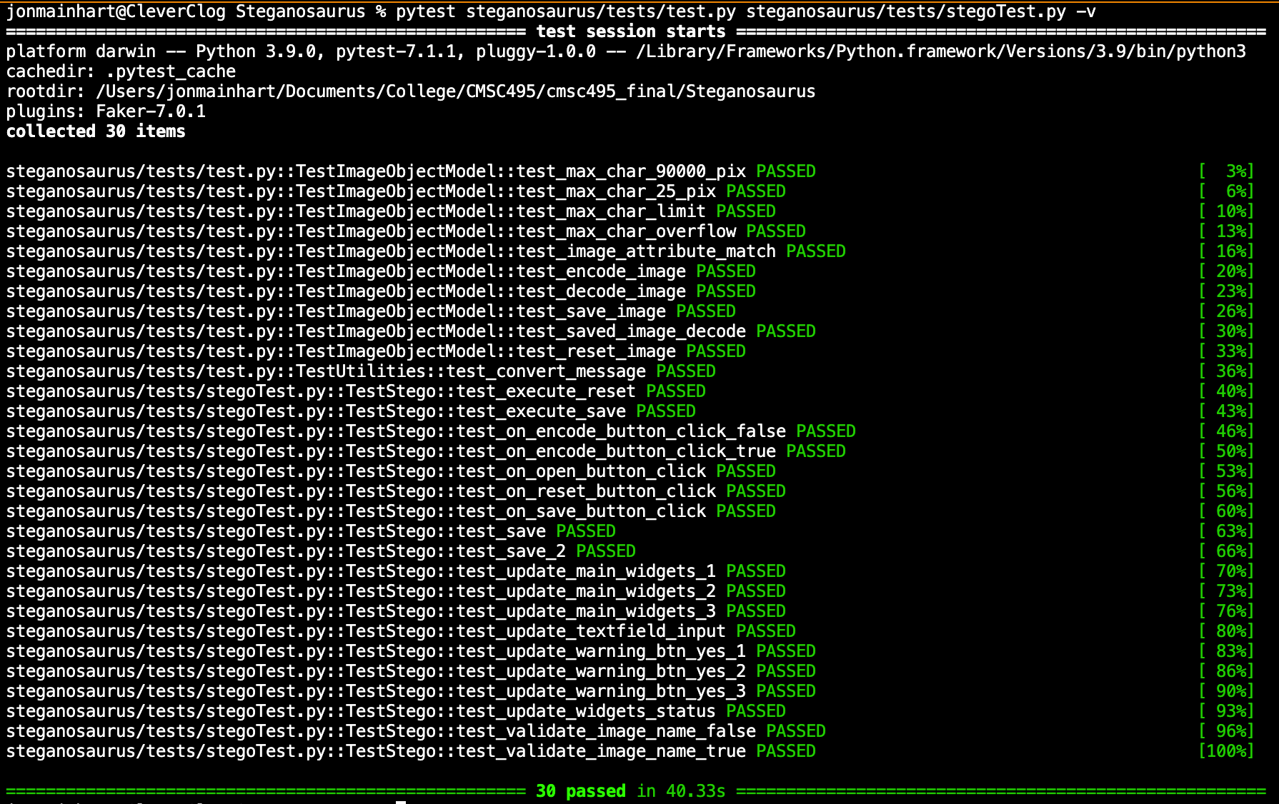

Figure 1. System 2 automated unit test results.

The 30 automated tests cover ImageObject methods used to encode, decode, calculate maximum message size, save, and reset images to their original state; binary encoding of messages; and front-end logic.

The manual testing of the application was successfully performed on all test systems. These tests included verifying that all buttons and fields worked as expected, that any expected user interaction worked as required, and that any unexpected user input was handled properly to prevent the application from crashing or operating outside of design parameters. The results of the tests contained in Table 7 begin with Figure 2.

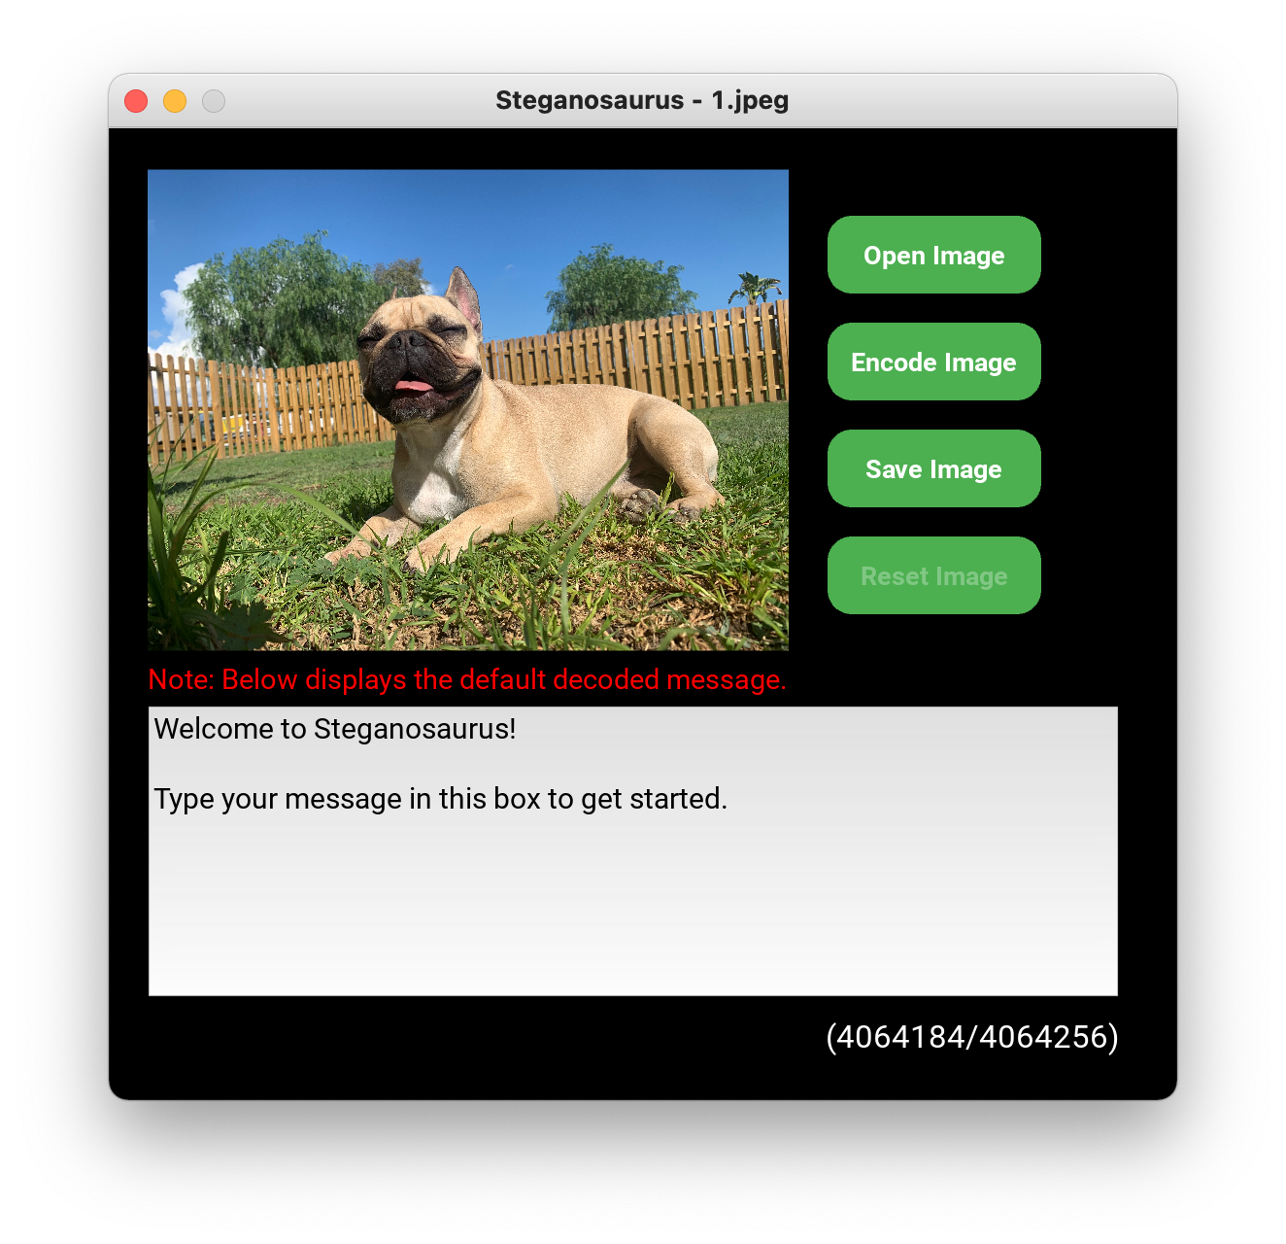

macOS

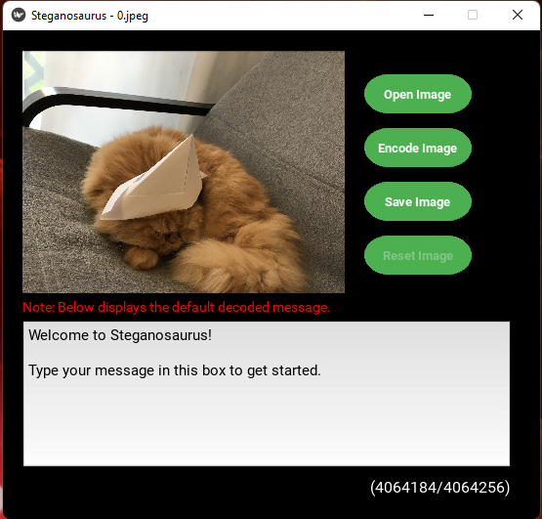

Windows

Figure 2. The application loads a randomized image when launched and decodes the secret message (manual test cases 4-1 and 4-2).

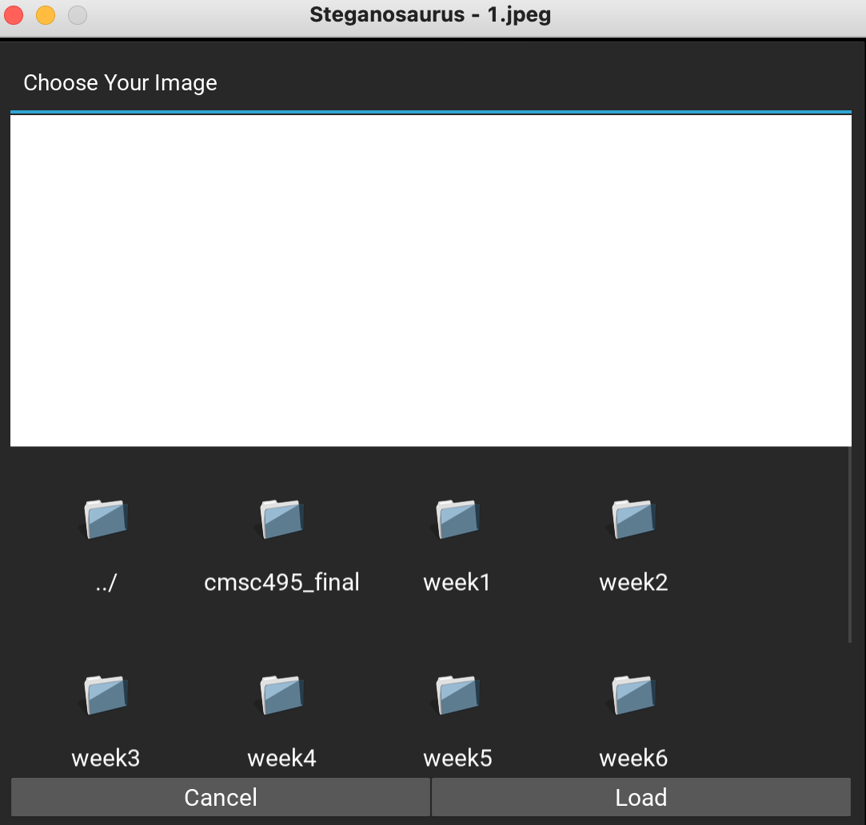

macOS

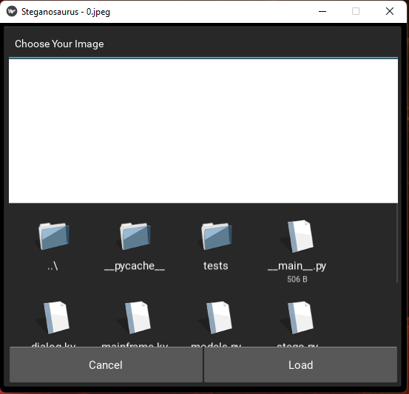

Windows

Figure 3. Results of clicking the “Open Image” button. The application has access to the file system (manual test cases 4-3 and 4-4).

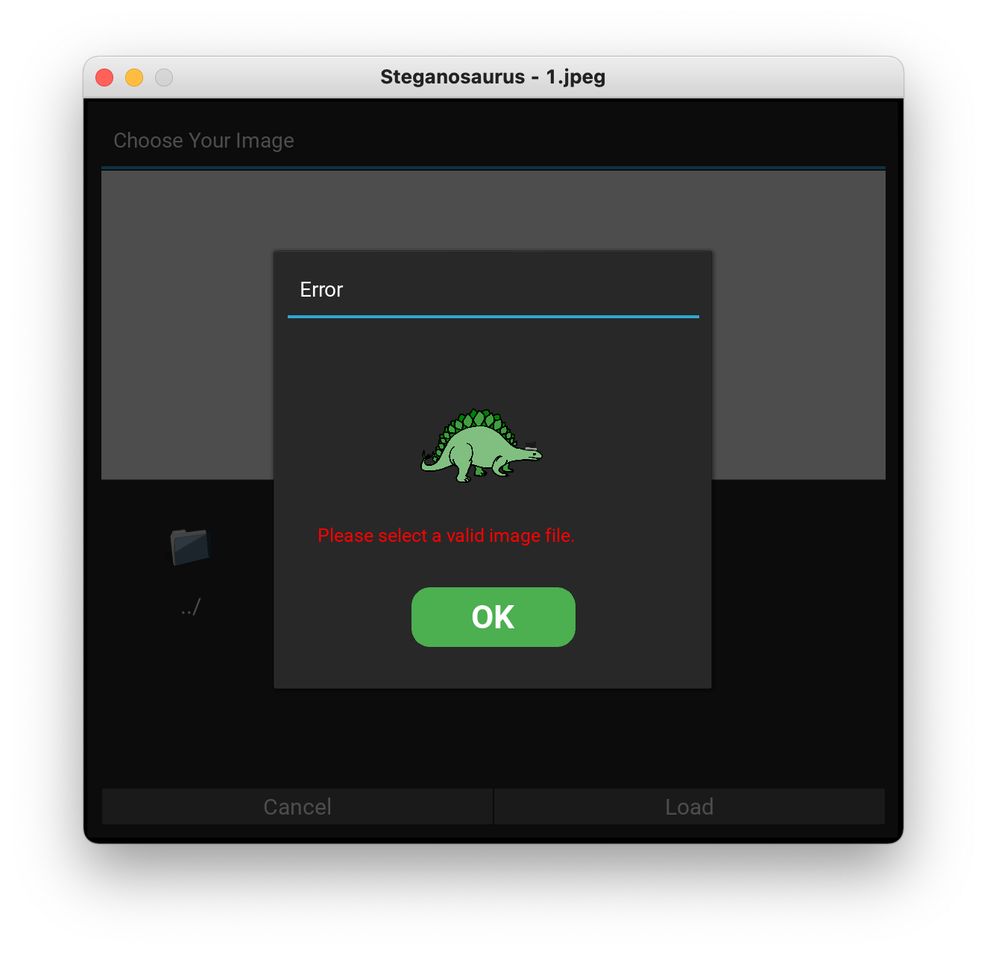

macOS

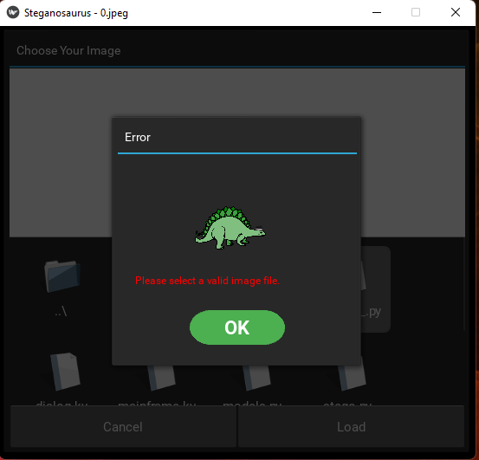

Windows

Figure 4. Results of attempting to open a ineligible file (Test case 4-5).

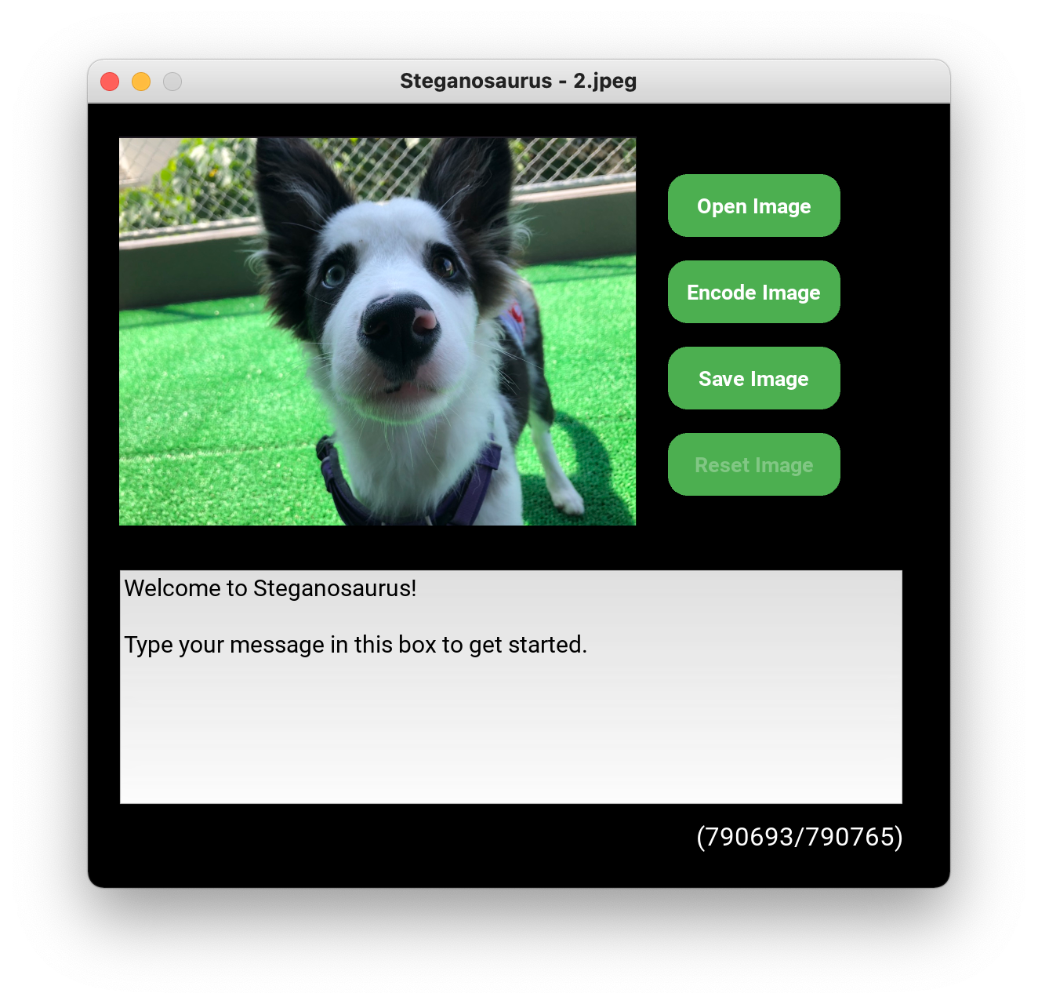

macOS

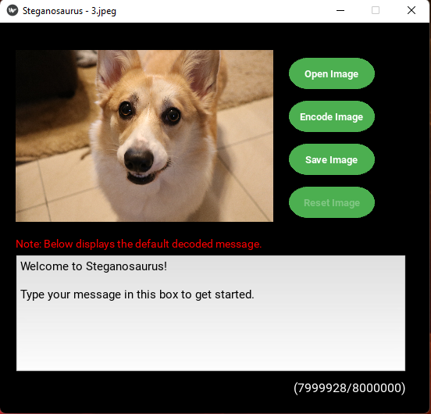

Windows

Figure 5. The application opens image files as expected (Test case 4-6).

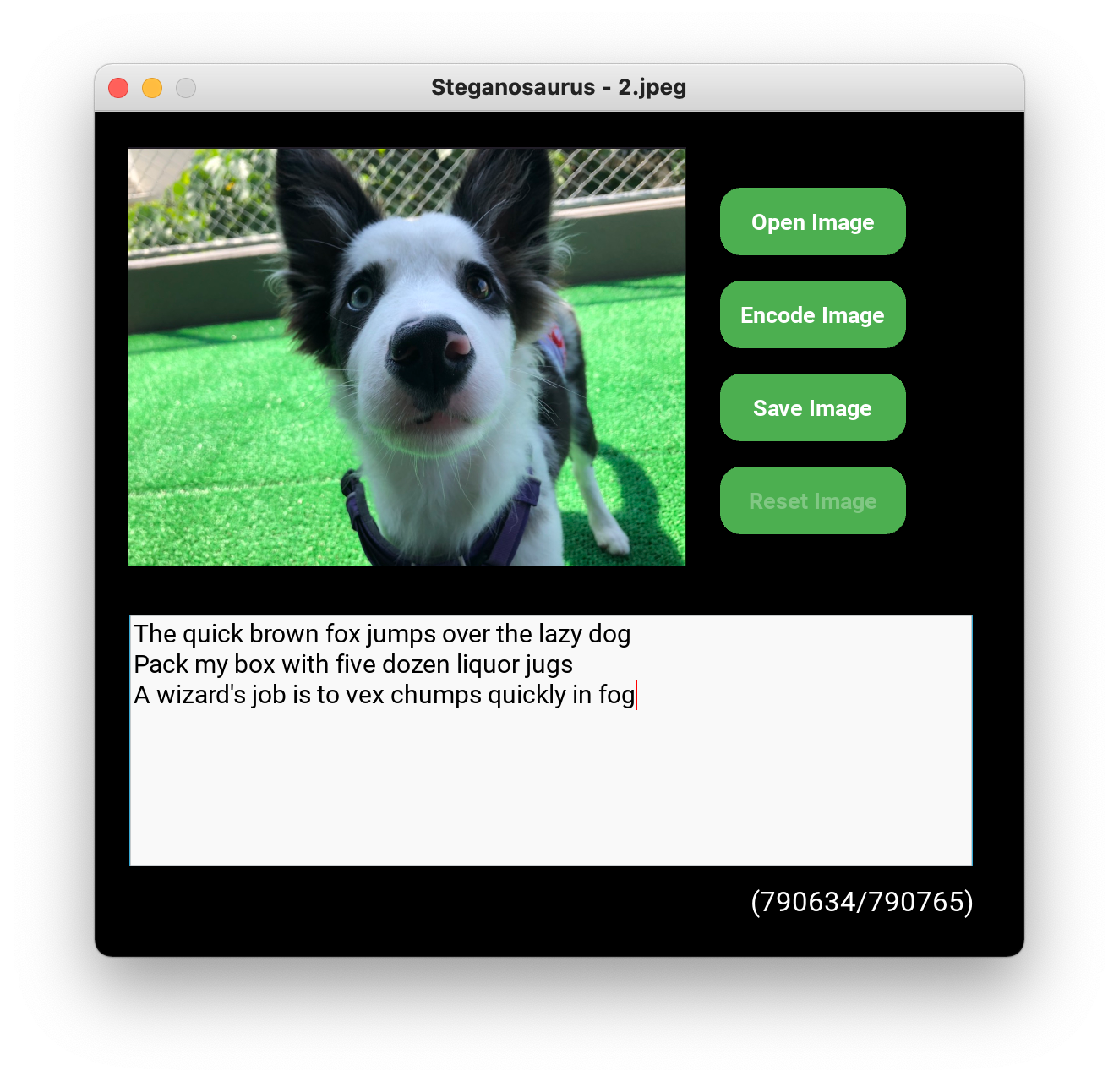

macOS

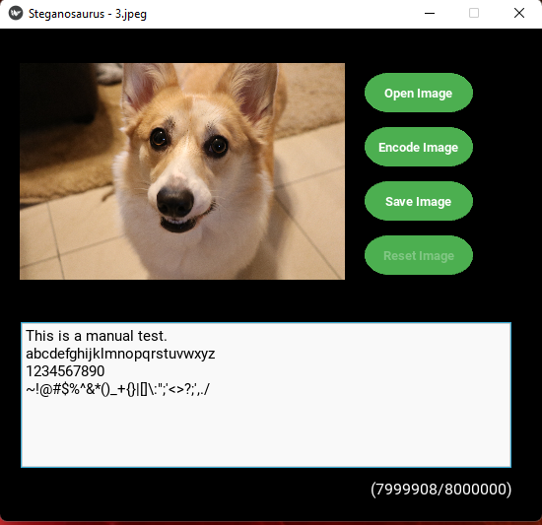

Windows

Figure 6. The remaining characters allowed decrease as text is input (Test case 4-8).

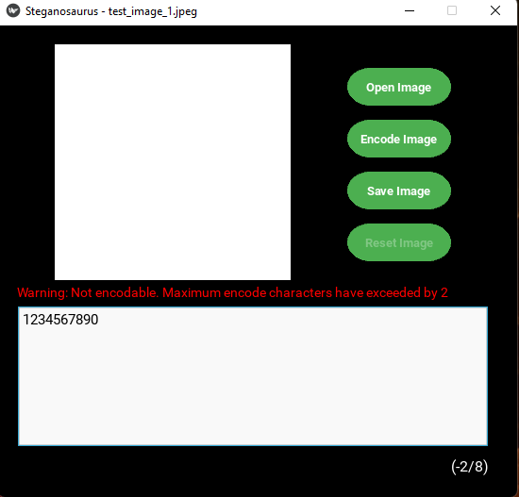

Windows

Figure 7. Entering too many characters displays a warning (Test case 4-9).

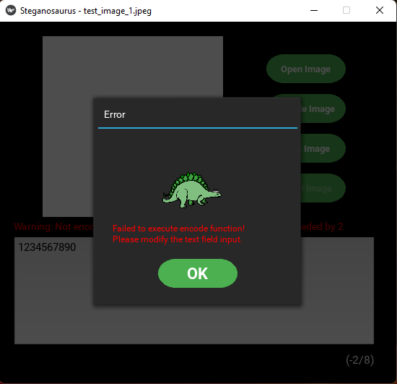

Windows

Figure 8. Attempting to encode an image with too many characters (Test case 4-10).

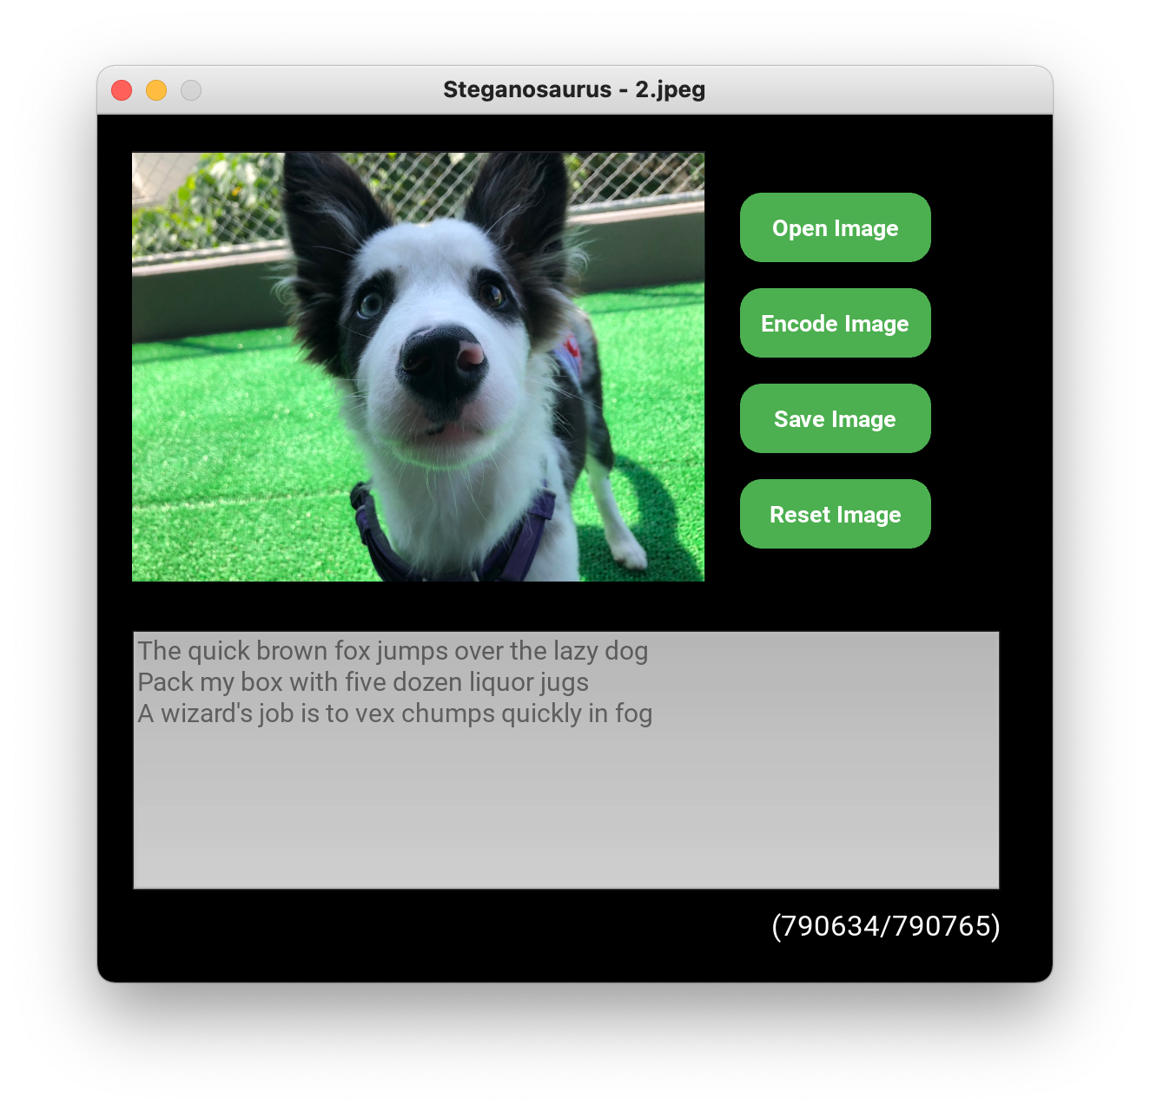

macOS

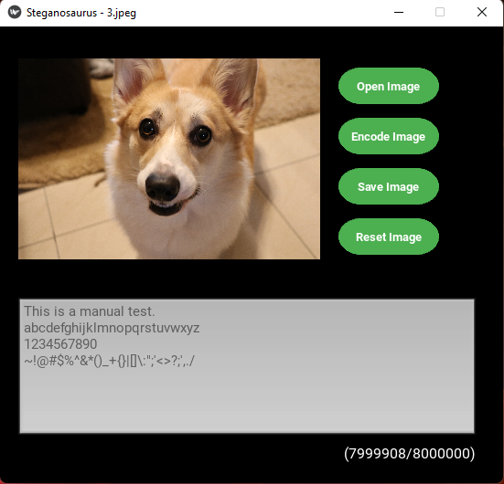

Windows

Figure 9. A message of the correct length will encode (Test case 4-11).

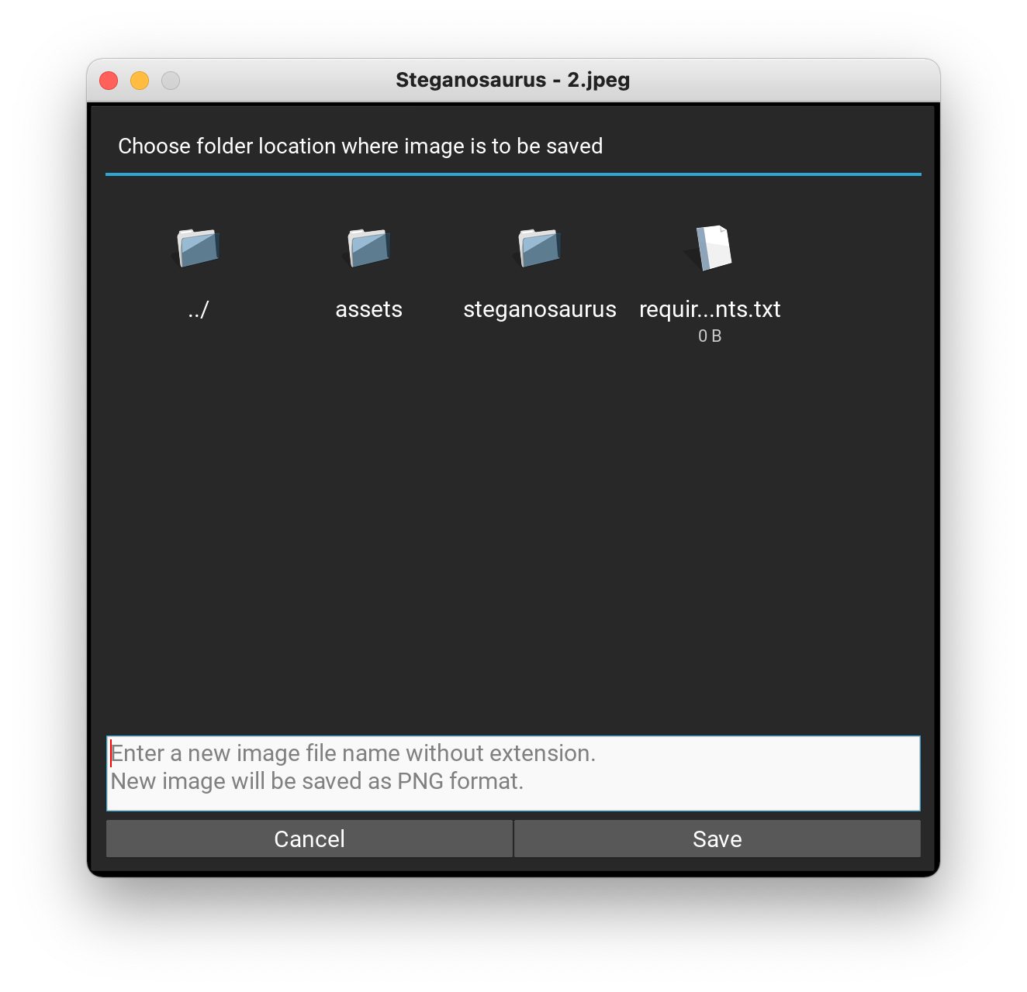

macOS

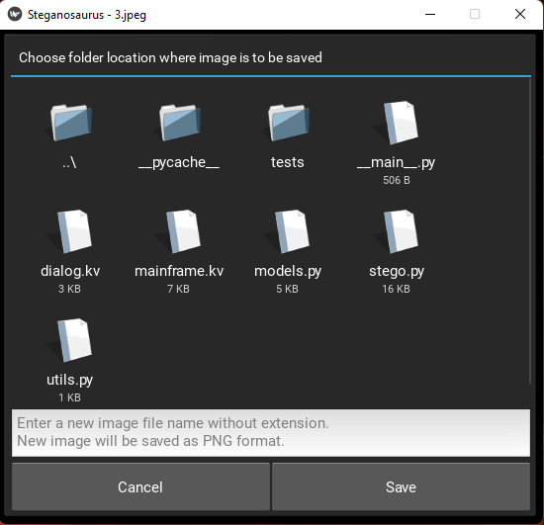

Windows

Figure 10. Save dialog (Test case 4-12).

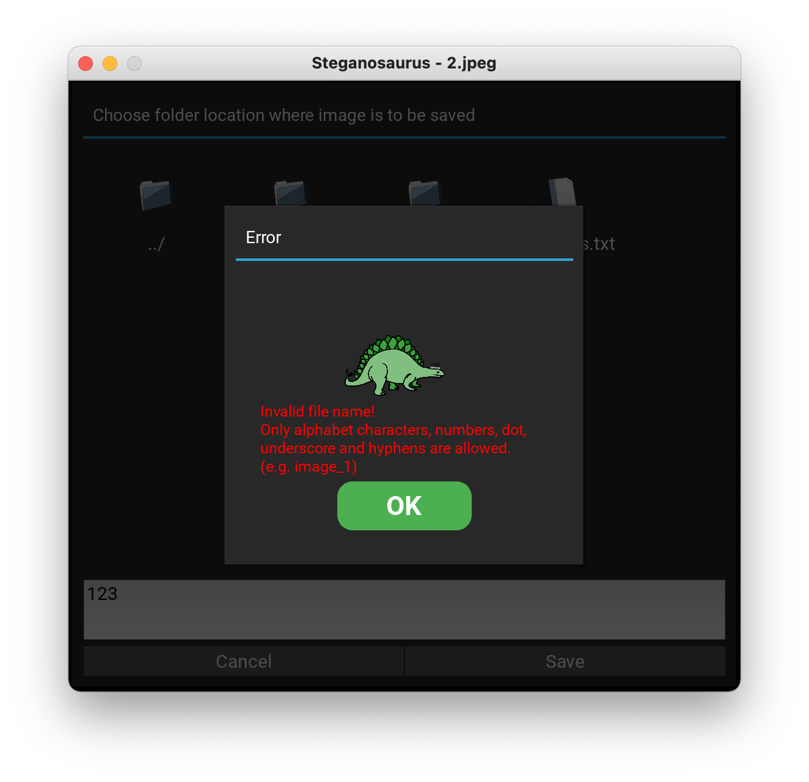

macOS

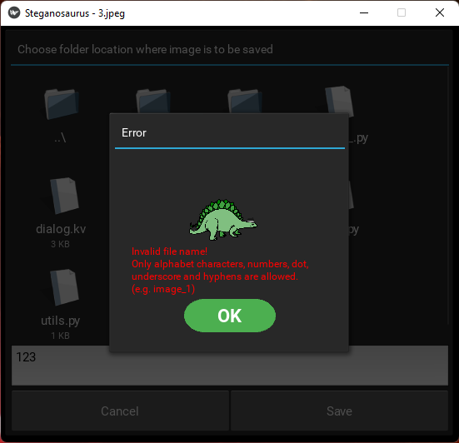

Windows

Figure 11. Attempting to save a file with an invalid name (Test case 4-13).

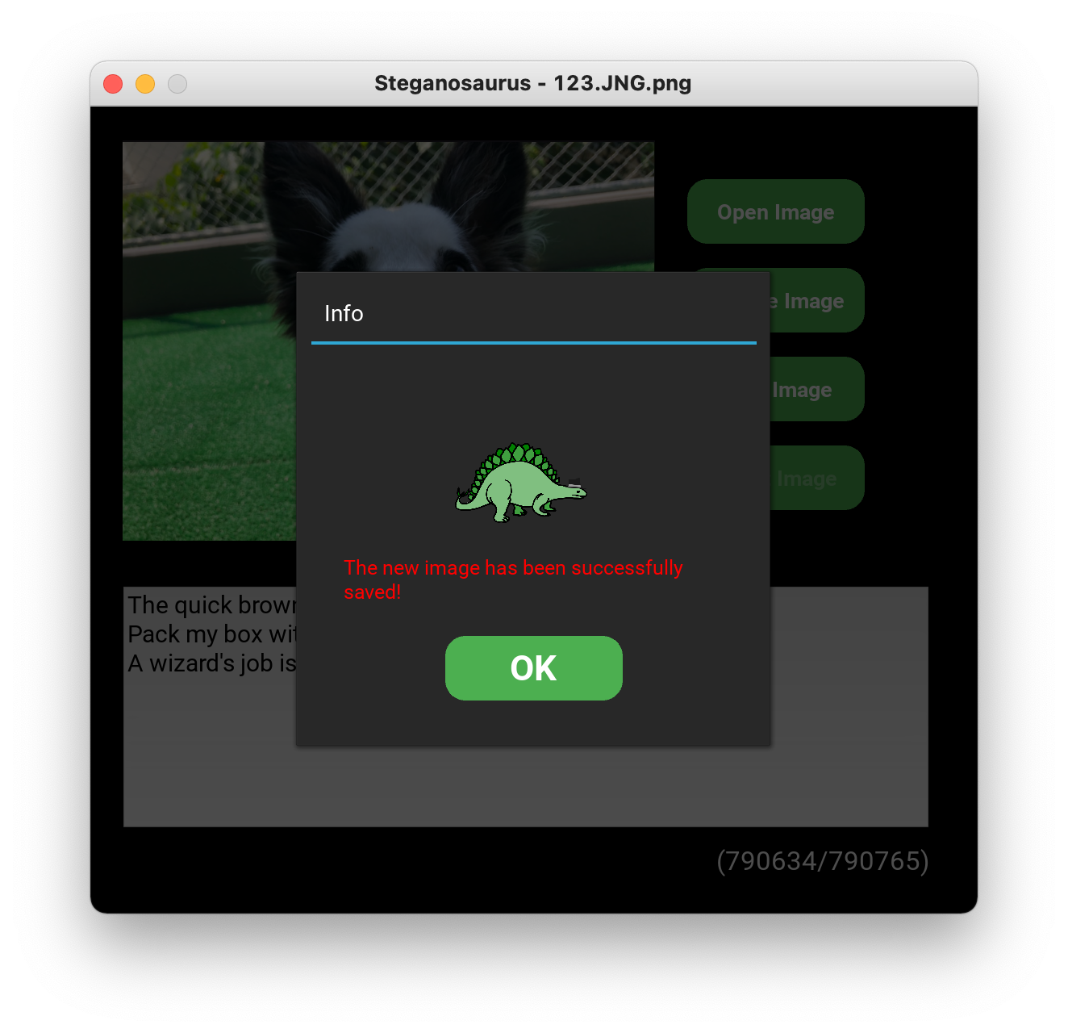

macOS

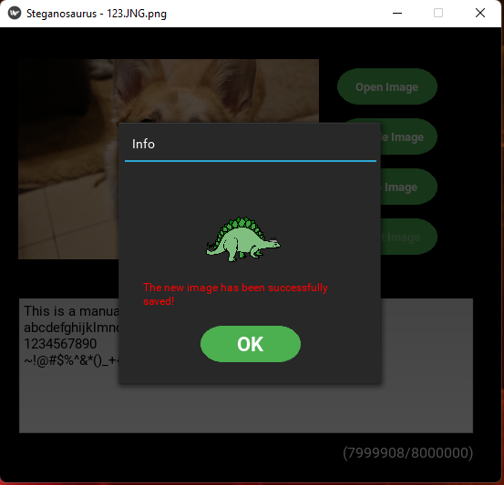

Windows

Figure 12. Successfully saving an image with default encoding (Test case 4-14).

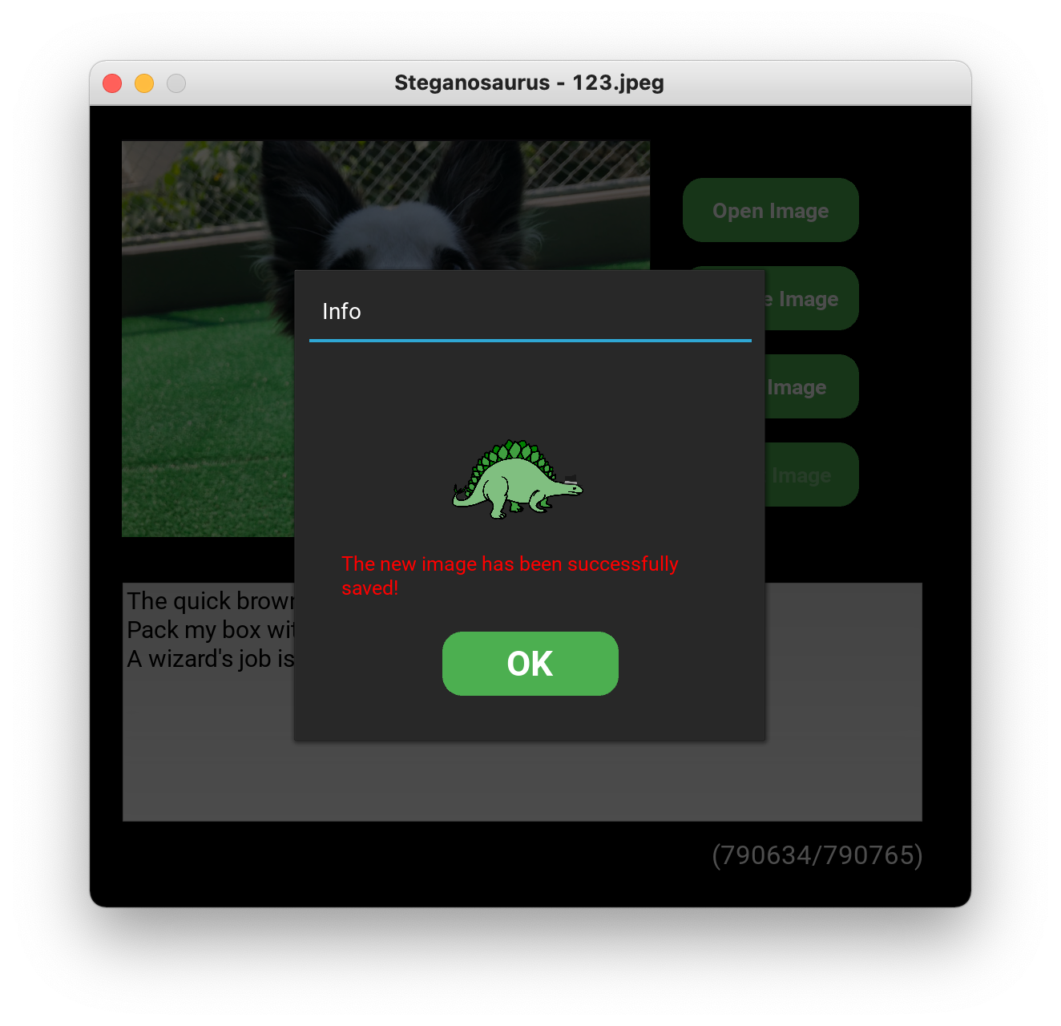

macOS

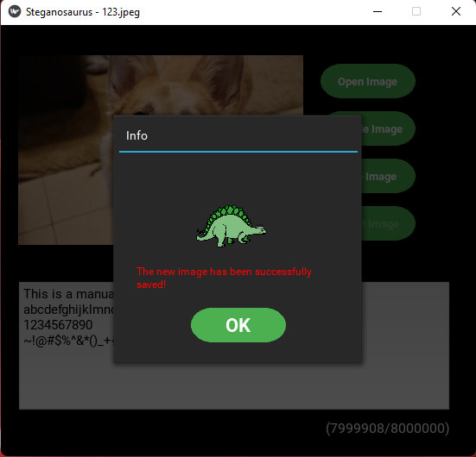

Windows

Figure 13. Successfully saving an image as JPEG (Test case 4-15).

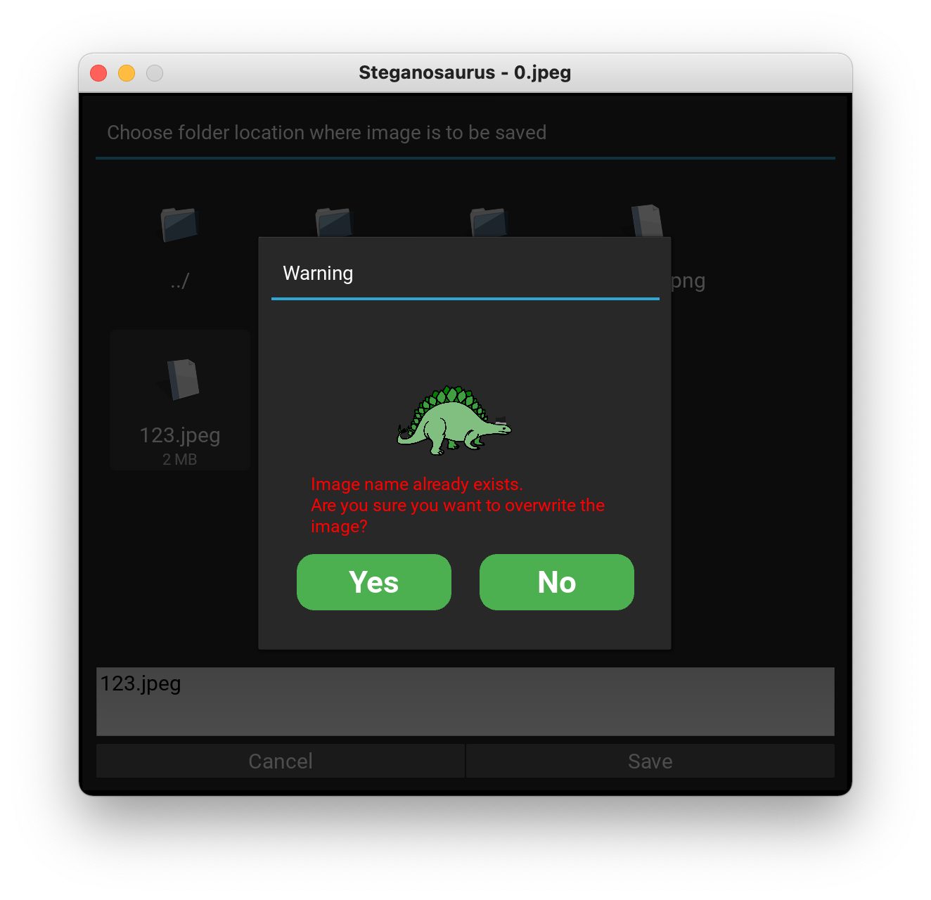

macOS

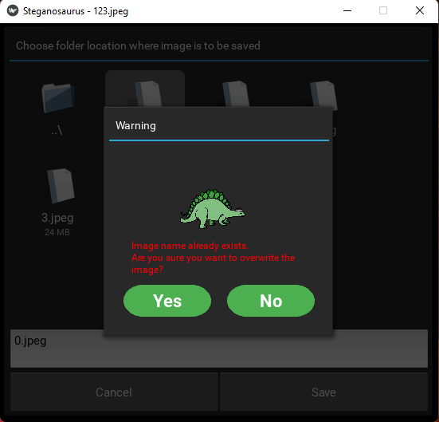

Windows

Figure 14. Attempting overwrite triggers warning (Test case 4-17).

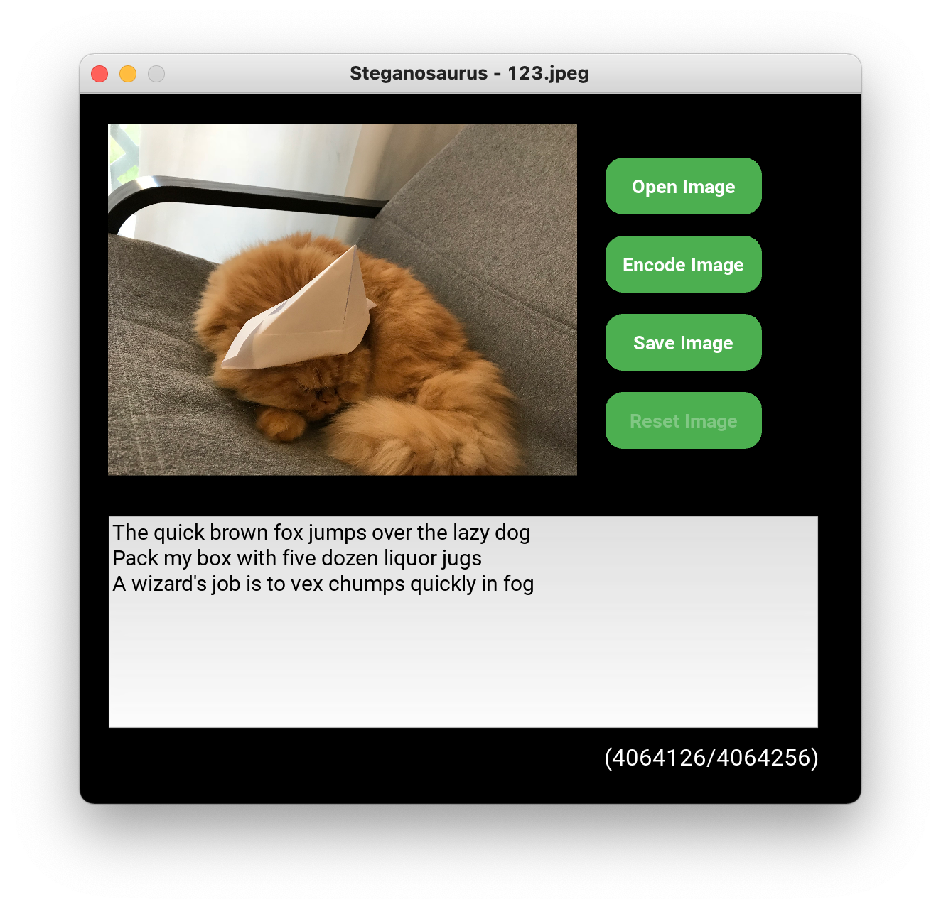

macOS

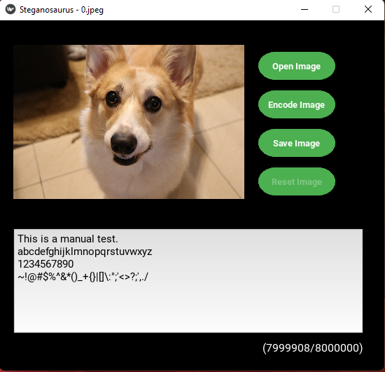

Windows

Figure 15. The files have been overwritten (Test case 4-17).

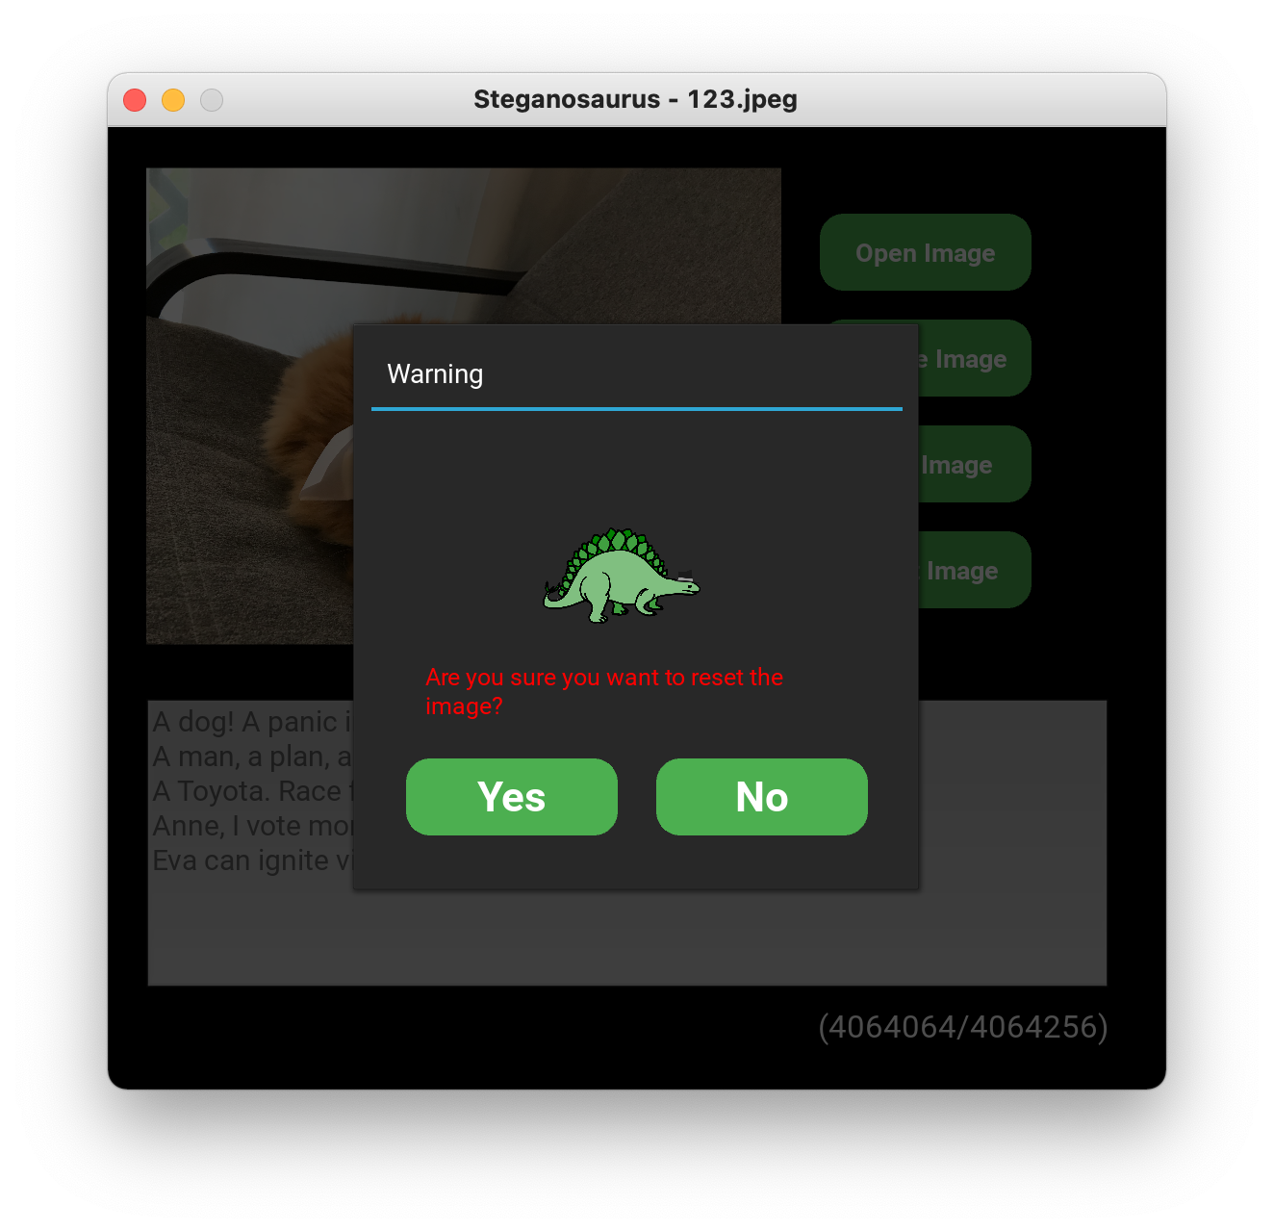

macOS

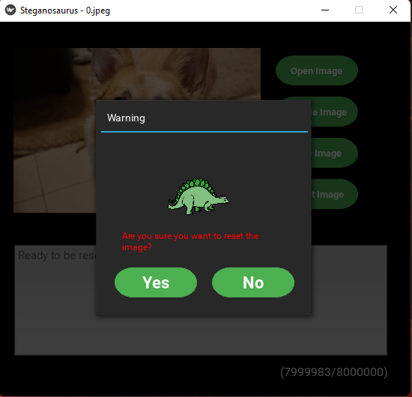

Windows

Figure 16. Reset button triggers warning (Test case 4-18).

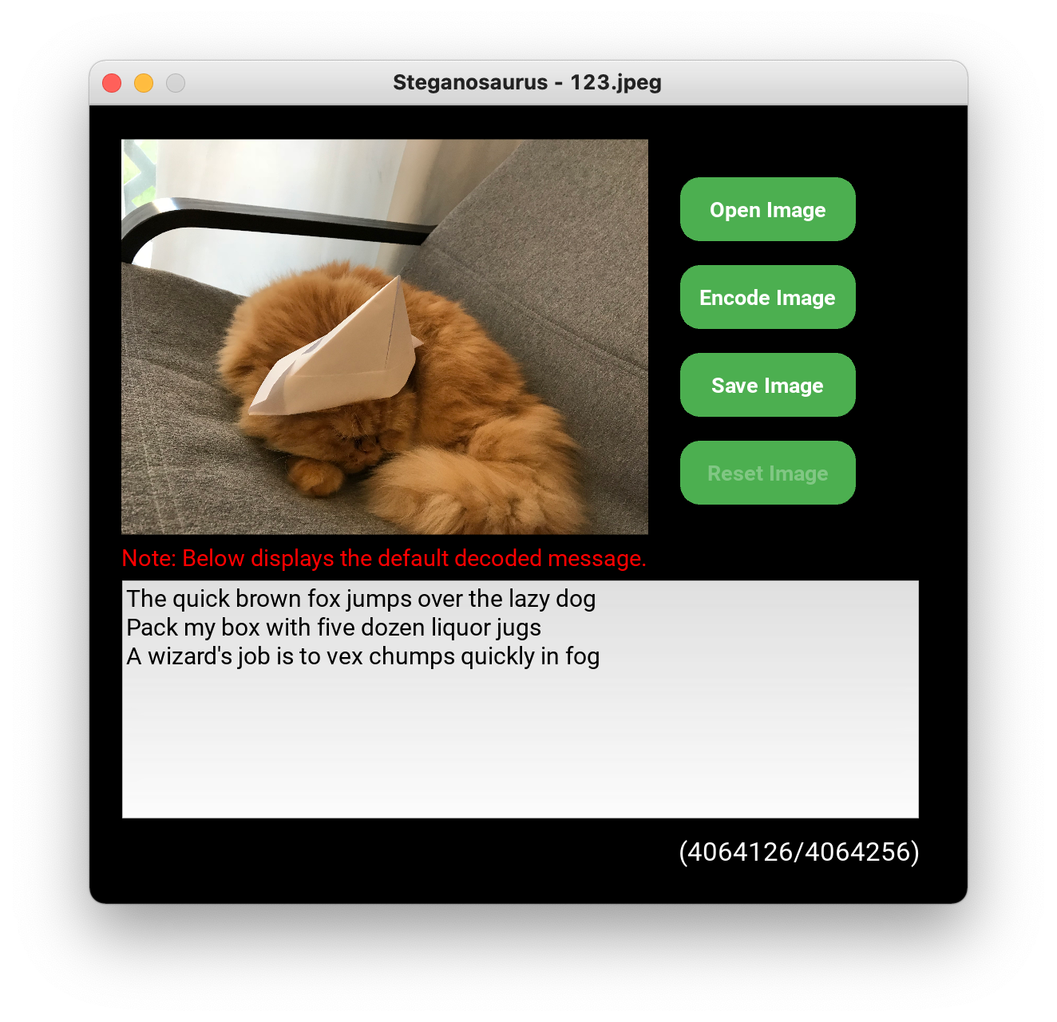

macOS

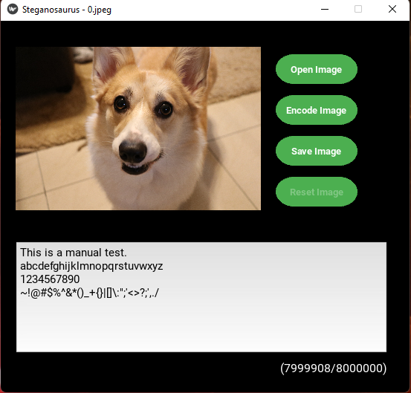

Windows

Figure 17. Image resets (Test case 4-18).

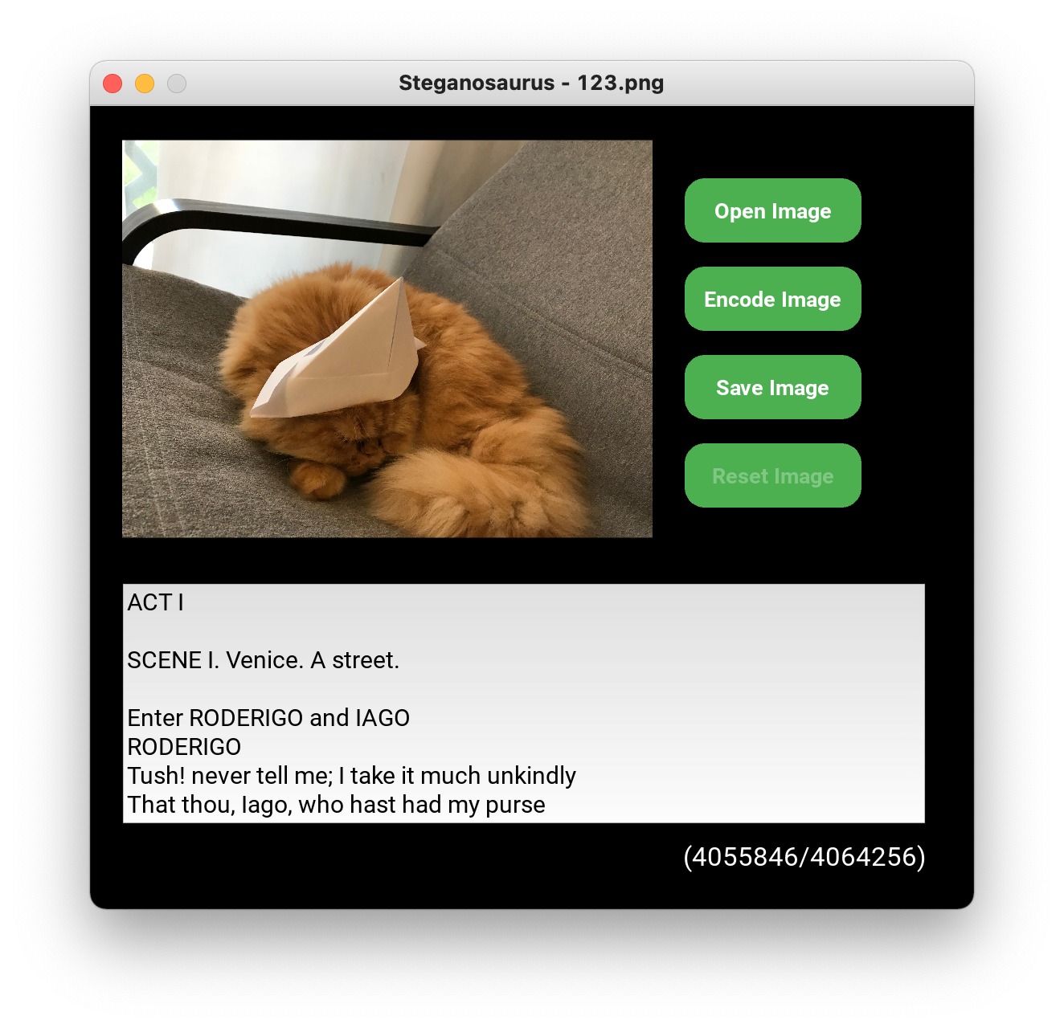

macOS

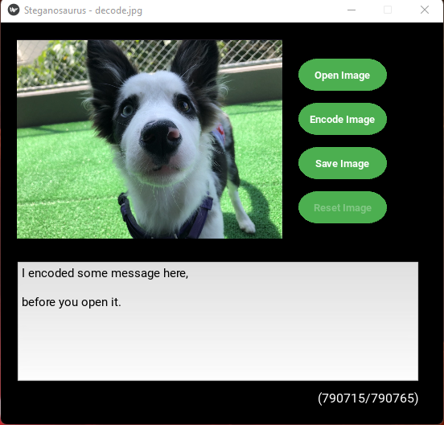

Windows

Figure 18. Image is decoded when opened (Test case 4-20).

# APPENDIX C: Project Design

## Project Overview

### Main Goals

Provide a GUI application which runs locally on any computer which meets the following minimum system requirements:

* Python 3.9 or greater installed
* Modules listed in requirements.txt installed
* A keyboard or similar text input device
* A mouse or similar pointing device
* A monitor or similar display capable of rendering images

Allow a single user to open an image file and view a secret text message that has been encoded in the pixel data.

Allow a user to enter a text message into a text input area and encode that text into the pixel data of an image.

Allow a user to save an encoded image file with the same or different filename.

Alert the user to any problems reading or writing files from within the application.

### Design Concept

The application will contain two main classes: MainFrame and ImageObject. The MainFrame class will contain the GUI event handlers and runtime variables. It relies on several sub-classes to implement different visual features such as pop-up warnings and file chooser windows. The ImageObject class will contain the image attributes such as filename and image data, as well as methods to encode and decode embedded text messages. There are utility functions which perform required tasks that do not fit into the object class paradigm.

### File Structure

The application files will be structured as shown in Figure 19.

Figure 19. File structure

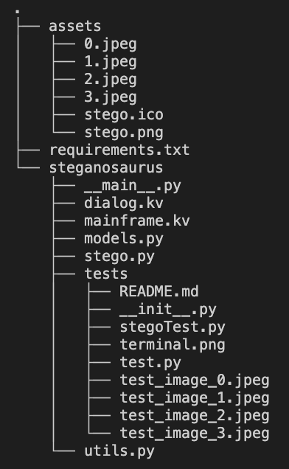

Figure 19. File structure

### File Access

The application will require read access to image files on the user’s system to enable the user to encode and decode messages inside of the pixel data of the images.

### Data Structures

An instance of an ImageObject will be declared at runtime. This object will use Python base types of String, Image, and int to record data about a user selected image.

User input will UTF-8 characters stored as a String.

### Input and Output

User text input will be entered using stdin.

User visual input will be entered using a mouse or similar pointing device controlled by the operating system.

Image files will be read from and written directly to the filesystem.

## Typical User Interaction

Figure 20 shows a typical user interaction with the application.

First, the user starts the program and chooses an image via the file selection interface. The image is then displayed to the user in the window.

Next, the image pixel data is then automatically extracted and sent to the message decoding algorithm. If a message can be decoded, it will be displayed inside the text input area of the window, otherwise a default message will be displayed.

Next, the maximum allowed character limit will be calculated and displayed to the user as a ratio of characters entered to characters allowed.

The user may then delete, edit, or append the text within the text input area until the character limit is reached. When the user is ready, they can push the “encode” button.

When the “encode” button is pressed, the user’s input will be converted to its binary value. The binary value of the message will then be used to encode the message in the RGB value of the image’s pixels.

Upon completion of the encoding process, the user may then choose to reset the pixel data to its original state, or to save the image for later use. The user will be alerted if they attempt to overwrite a file.

If the image is reset, the original message (if any) will be displayed in the text input area.

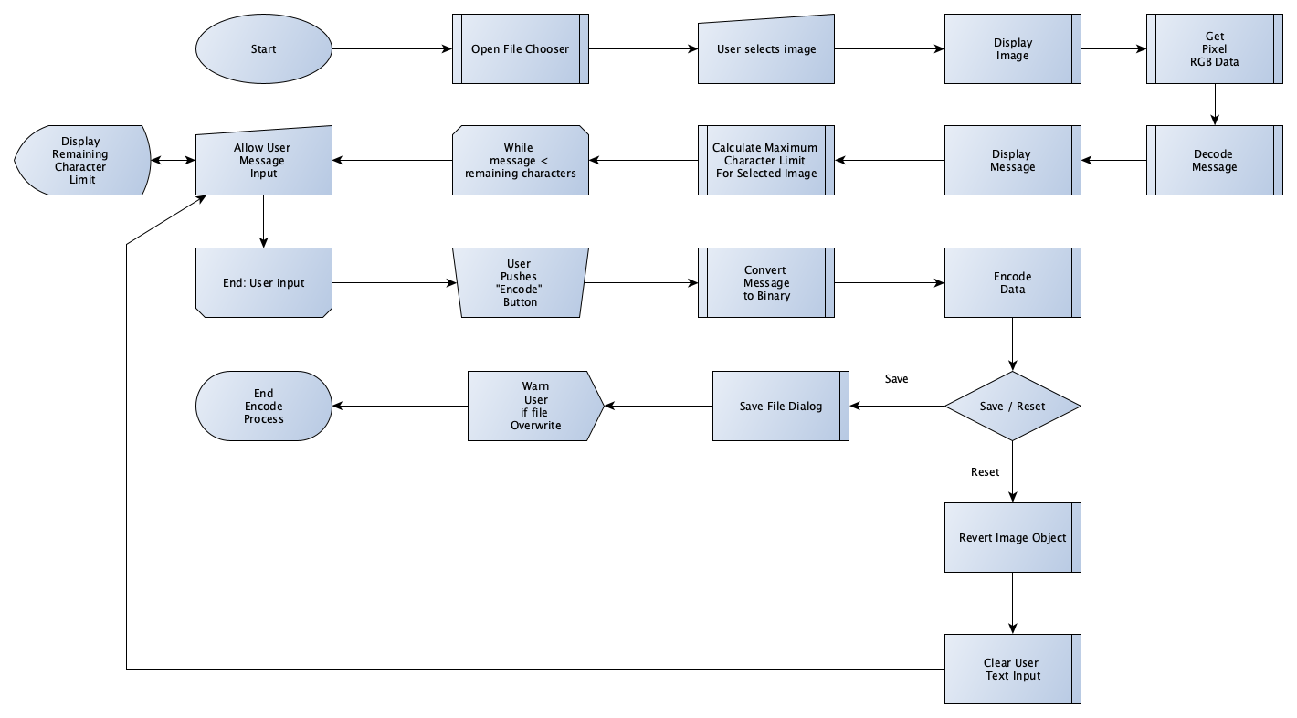

Figure 20. Logic Control Flow of a typical user interaction

## User Interface

### GUI Overview

The Graphical User Interface (GUI) of the application shown in Figure 21 will have an image display area and four function buttons on the right side of the image in the upper half of the window. The function buttons include “Open Image”, “Encode Image”, “Reset Image” and “Save Image”. The “Reset Image” button will be initially disabled until an image is successfully encoded. There will be a text input field at the bottom of the GUI to enable the user to enter the secret data to be encoded and to read messages that have been decoded from images. There will be one label between the text field and the image display area to display warning messages regarding the text field (e.g., Warning: Maximum encode character number has been reached) and a label below the text field displaying a ratio expressing the remaining number of characters to the maximum allowed.

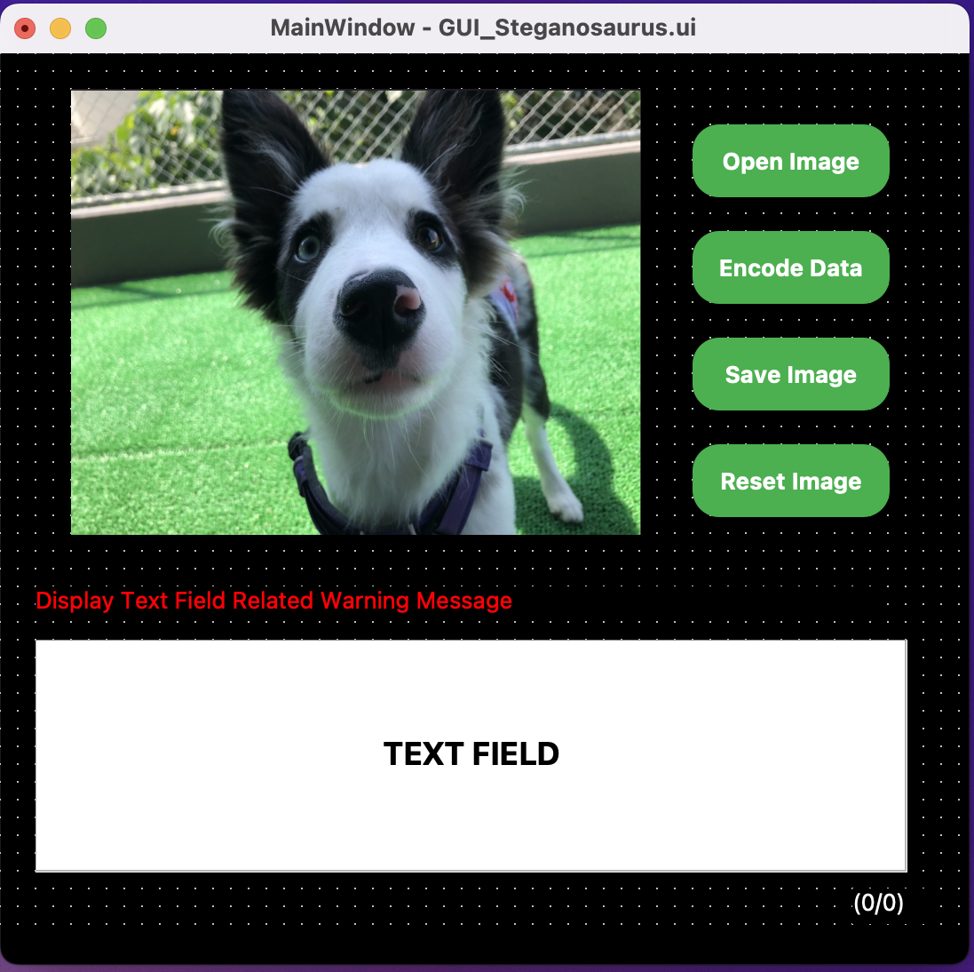

Figure 21. Graphical User Interface

### User Notification Dialog

User messages resulting from errors and runtime exceptions will be displayed in a popup dialog as shown in Figure 22 and Figure 23. The application icon will be displayed in the upper center of the popup dialog and the message will be displayed under the icon. At the bottom of the popup dialog there will be an “OK” button for the “info” and “error” type message that enables the user to click the button and close the popup dialog. For the “warning” type message, there will be two buttons under the message display label, that gives the user an option to click either “Yes” to continue or “No” to cancel.

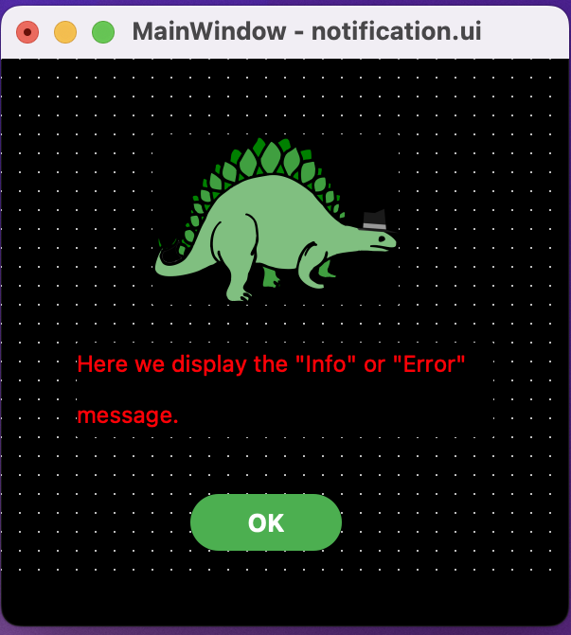

Figure 22. Info and error message popup dialog

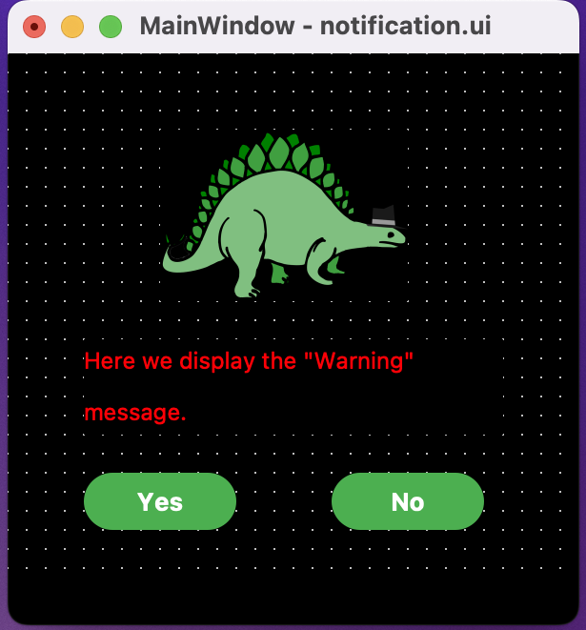

Figure 23. Warning message popup dialog

## Message Encoding and Decoding

### Encoding an Image

Messages will be encoded into the target image by first extracting the image pixel data into a list of tuples which represent the red, green, and blue (RGB) color values of the image.

Next, each character of the user’s message will be converted to its 8-bit binary ASCII value. The 8-bit values will then be used to shift the RGB values to be either an even number to represent a binary zero, or an odd number to represent a binary one. Pixels will be read 3 at a time which will allow one 8-bit character to be encoded. The remaining bit of each set will tell the decoder to either continue reading (binary one), or to stop (binary zero) when the message is later decoded.

### Decoding an Image

Messages will be decoded by first extracting the image pixel data into a list of tuples which represent the RGB color values of the image.

Next, the color value will be determined to be either even or odd. An even number will result in a binary 0 being appended to a string, an odd value will result in a binary 1 being appended to the same string. The ninth color value will determine whether to continue reading (binary 1), or to stop reading (binary 0) and will be discarded.

Next, the string of binary digits will be converted to a string of characters and returned.

### Resetting an Image

Images may be reset to their original state by copying the values of the backup_pixel_data to the rgb_pixel_data attribute. The backup_pixel_data attribute shall be immutable.

## Class, Attributes, and Methods

The following tables list the classes, attributes, and methods.

Table 8**:** stego.py – MainFrame class

|  |  |  |
| --- | --- | --- |
| **Attribute** | **Type** | **Source** |
| main_title | String | MainFrame App |
| message | String | MainFrame App |
| message_type | String | MainFrame App |
| file_spliter | String | MainFrame App |
| current_filename | String | MainFrame App |
| LEGO_PATH | String | MainFrame App |
| reset_btn_disabled | BooleanProperty | MainFrame App, default value: True  on_encode_button_click() |
| textfield_disabled | BooleanProperty | MainFrame App, default value: False |
| image_saver_dismiss | BooleanProperty | MainFrame App, default value: False |
| valid_image_name | BooleanProperty | MainFrame App, default value: True |
| MESSAGE_TYPE | Enum | MainWidget class |
| WARNING_TYPE | Enum | MainWidget class |
| display_image | ImageObject | MainWidget class |
| new_filename | String | MainWidget class |
| warning_type | String | MainWidget class |
| new_filepath | String | MainWidget class |
| encodable_bool | Boolean | MainWidget class |
| user_notification_msg | StringProperty | MainWidget class,  Set up value dynamically |
| textfield_str | StringProperty | MainWidget class, GUI TextInput |
| maximum_char_count | NumericProperty | display_image.max_available_chars |
| **Method** | **Input** | **Output** |
| on_open_button_click | self | ImageChooserPopup().show_load_list() |
| on_encode_button_click | self | MainWidget.display_image.encode_image() |
| on_reset_button_click | self | self.popup_user_notification() |
| execute_reset | self | MainWidget.display_image.reset_image() |
| on_save_button_click | self | ImageSaverPopup().show_filechooser() |
| save | self,  String: new_filepath  String: new_filename | self.update_warning_btn_yes()  self.popup_user_notification() |
| execute_save | self | MainWidget.display_image.save_image()  MainWidget.display_image.decode_image() |
| validate_image_name | self,  String: image_name | self.popup_user_notification(), Boolean |
| popup_user_notification | self, String: message, String: message_type | WarningPopup().open()  InfoAndErrorPopup().open() |
| update_warning_btn_yes | self,  Boolean: image_warning_btn_yes | self.update_textfield_input()  self.execute_reset()  self.execute_save()  self.update_widgets_status() |
| update_widgets_status | self,  String: reset_btn_disabled,  String: textfield_disabled, String:  image_saver_dismiss | N/A |
| update_main_widgets | self, *args | N/A |
| update_textfield_input | self | N/A |

Table 9: stego.py – ImageChooserPopup class

|  |  |  |
| --- | --- | --- |
| **Attribute** | **Type** | **Source** |
| file_path | String | selected() |
| **Method** | **Input** | **Output** |
| __init__ | self, **kwargs | Cache.remove() |
| show_load_list | self | self.open() |
| selected | self, String: filename | file_path  MainWidget.popup_user_notification() |
| load_list | self | MainWidget.display_image  self.dismiss() |

Table 10: stego.py – ImageSaverPopup class

|  |  |  |
| --- | --- | --- |
| **Method** | **Input** | **Output** |
| __init__ | self, **kwargs | Clock.schedule_interval() |
| show_filechooser | self | self.open() |
| dismiss_popup | self, *args | MainWidget.display_image  self.dismiss() |

Table 11: mainframe.kv – MainFrame template

|  |  |  |  |
| --- | --- | --- | --- |
| **Element Name** | **Type** | **Properites** | **Action** |
| MainFrame | Main Interface | id: main_widget  background-color: black  size: 550x500 | N/A |
| DisplayImage | Image | id: main_image  source: display_image.filename  size: 330x250 | N/A |
| OpenImageButton | Button | id: open_btn  background-color: # 4CAF50  text color: white  text: Open Image  size: 110x40  enabled by default: True | on_open_button_click() |
| EncodeImageButton | Button | id: encode_btn  background-color: # 4CAF50  text color: white  text: Encode Image  size: 110x40  enabled by default: True | on_encode_button_click()  enables when file opened |
| ResetImageButton | Button | id: reset_btn  background-color:  enabled - # 4CAF50  disabled – grey  text color: white  text: Reset Image  size: 110x40  enabled by default: False | on_reset_button_click()  enables when message encoded |
| SaveImageButton | Button | id: save_btn  background-color: # 4CAF50  text color: white  text: Save Image  size: 110x40  enabled by default: True | on_save_button_click()  enables when file opened |
| MessageLabel | Label | default text: warning message  size: 550x40  text color: red | N/A |
| TextCounterLabel | Label | default text: (0/0) No Image Loaded  text: (n/p) characters remaining  text: Maximum (p) characters entered  size: 500x30  text color: white | N/A |
| GUITextInput | TextInput | default text: decoded message from loaded image  text: User Input  size: 500x150 | N/A |
| RoundedCornerButton | Button | on_press: set background color to #3E8E41  on_release: set color back to # 4CAF50  canvas.before: set rounded rectangle to the button | N/A |
| WarningPopup | Popup | id: warning_dialog  size: 300x300  WarningDialog | title: app.message_type  dynamically display message type |
| InfoAndErrorPopup | Popup | id: warning_dialog  size: 300x300  InforAndErrorDialog | title: app.message_type  dynamically display message type |
| ImageChooserPopup | Popup | Size: 550x500  FileImage  FileChooserIconView  CancelButton  LoadButton | N/A |
| FileImage | Image | id: file_image  source: “” | N/A |
| FileChooserIconView | FileChooserIconView | id: file_chooser | on_selection: root.selected(file_chooser.selection) Pass the file path of selected image to stego.py |
| CancelButton | Button | Not Defined | On_release: root.dismiss() |
| LoadButton | Button | Not Defined | on_press: app.root.update_textfield_input()  on_release: root.load_list() |
| ImageSaverPopup | Popup | Size: 550x500  FileImage  FileChooserIconView  TextInput  CancelButton  SaveButton | N/A |
| FileChooserIconView | FileChooserIconView | id: file_chooser | on_selection: new_image_name.text |
| NewImageName | TextInput | id: new_image_name |  |
| CancelButton | Button | Not Defined | On_release: root.dismiss() |
| SaveButton | Button | Not Defined | on_release: app.root.save() |

Table 12: dialog.kv – PopupDialogWidget template

|  |  |  |  |
| --- | --- | --- | --- |
| **Element Name** | **Type** | **Properites** | **Action** |
| WarningDialog | Widget | DialogIconLabel  DialogNotificationLabel  DialogButtonYes  DialogButtonNo | N/A |
| InforAndErrorDialog | Widget | DialogIconLabel  DialogNotificationLabel  DialogButtonOK | N/A |
| DialogIconLabel | Label | background-color: black  size: 220x50 | N/A |
| DialogNotificationLabel | Label | text color: red  size: 220x60  position: BoxLayout default  spacing: 20  padding: 5 | N/A |
| DialogButtonYes | Button | background-color: # 4CAF50  text color: white  size: 110x40  position: BoxLayout default  enabled by default: True | on_press: app.root.update_warning_btn_yes(True) |
| DialogButtonNo | Button | background-color: # 4CAF50  text color: white  size: 110x40  position: BoxLayout default  enabled by default: True | on_press: app.root.update_warning_btn_yes(False) |
| DialogButtonOK | Button | background-color: # 4CAF50  text color: white  size: 110x40  position: BoxLayout center  enabled by default: True | N/A |

Table 13: models.py – ImageObject class

|  |  |  |
| --- | --- | --- |
| **Attribute** | **Type** | **Source** |
| filename | String | open_image() |
| max_available_chars | int | self.calculate_max_chars() |
| _backup_image | Image | Image.open(self.filename, ‘r’) |
| _image | Image | _backup_image.copy() |
| **Method** | **Input** | **Output** |
| __init__() | self, filename | ImageObject |
| _calculate_max_chars() | self | int |
| _modify_pixels() | self, data: list | tuple generator |
| encode_image() | self, String | Image |
| decode_image() | self | String |
| reset_image() | self | Image |

Table 14: utils.py – Utility Functions

|  |  |  |
| --- | --- | --- |
| **Function** | **Input Parameters** | **Return Value** |
| convert_message() | String: user_input | list: converted_message(08b) |
| random_img() | None | str: random file from assets folder |